|  |  |  |  |  |  |  |
| --- | --- | --- | --- | --- | --- | --- |
| DBMS | Dataset Size | Optimization | Execution Time (ms) | | | |
| Q1 Simple Selection | Q2 Range Query | Q3 Aggregation | Q4 Filter + Sort |
| Postgre SQL | 100k | Yes | 3.841 | 3.158 | 40.192 | 0.032 |
| No | 4.968 | 21.496 | 44.736 | 13.297 |
| 500k | Yes | 20.001 | 55.122 | 101.731 | 0.069 |
| No | 46.691 | 105.317 | 173.258 | 80.227 |
| 1000k | Yes | 58.618 | 38.365 | 176.843 | 0.051 |
| No | 125.630 | 170.898 | 247.195 | 176.011 |
| MongoDB | 100k | Yes | 44 | 19 | 107 | 1 |
| No | 166 | 118 | 105 | 0 |
| 500k | Yes | 402 | 151 | 495 | 0 |
| No | 1065 | 452 | 617 | 0 |
| 1000k | Yes | 855 | 427 | 1087 | 0 |
| No | 2348 | 1002 | 1109 | 0 |
| Cassandra | 100k | Yes | 3.092 | 6.273 | 811.395 | 110.697 |
| No | 9.604 | 81.245 | 4947.532 | 255.601 |
| 500k | Yes | 1.490 | 77.300 | 132.008 | 137.032 |
| No | 10.033 | 49.144 | 5151.909 | 2.141 |
| 1000k | Yes | 11.953 | 60.480 | 8725.636 | 14.446 |
| No | 10.151 | 52.531 | 10000.480 | 2.741 |

Master Performance Result

Optimization Comparison Table

|  |  |  |  |  |  |  |
| --- | --- | --- | --- | --- | --- | --- |
| DBMS | Dataset Size | Optimization | Execution Time | | | |
| Q1 Simple Selection | Q2 Range Query | Q3 Aggregation | Q4 Filter + Sort |
| Postgre SQL | 100k | Yes | 3.841 | 3.158 | 40.192 | 0.032 |
| No | 4.968 | 21.496 | 44.736 | 13.297 |
| Improvement Percentage | | 29.34% | 581% | 11.31% | 41453.13% |
| 500k | Yes | 20.001 | 55.122 | 101.731 | 0.069 |
| No | 46.691 | 105.317 | 173.258 | 80.227 |
| Improvement Percentage | | 133.44% | 91.06% | 70.31% | 116171.01% |
| 1000k | Yes | 58.618 | 38.365 | 176.843 | 0.051 |
| No | 125.630 | 170.898 | 247.195 | 176.011 |
| Improvement Percentage | | 114.32% | 345.45% | 39.78% | 345019.61% |
| MongoDB | 100k | Yes | 44 | 19 | 107 | 1 |
| No | 166 | 118 | 105 | 0 |
| Improvement Percentage | | 277.27% | 521.05% | -1.87% | -100.00% |
| 500k | Yes | 402 | 151 | 495 | 0 |
| No | 1065 | 452 | 617 | 0 |
| Improvement Percentage | | 164.93% | 199.34% | 24.65% | NaN |
| 1000k | Yes | 855 | 427 | 1087 | 0 |
| No | 2348 | 1002 | 1109 | 0 |
| Improvement Percentage | | 174.62% | 134.66% | 2.02% | NaN |
| Cassandra | 100k | Yes | 3.092 | 6.273 | 811.395 | 110.697 |
| No | 9.604 | 81.245 | 4947.532 | 255.601 |
| Improvement Percentage | | 210.61% | 1195.15% | 509.76% | 130.90% |
| 500k | Yes | 1.490 | 77.300 | 132.008 | 137.032 |
| No | 10.033 | 49.144 | 5151.909 | 2.141 |
| Improvement Percentage | | 573.36% | -36.42% | 3802.72% | -98.44% |
| 1000k | Yes | 11.953 | 60.480 | 8725.636 | 14.446 |
| No | 10.151 | 52.531 | 10000.480 | 2.741 |
| Improvement Percentage | | -15.08% | -13.14% | 14.61% | -81.03% |

|  |  |  |  |  |  |  |
| --- | --- | --- | --- | --- | --- | --- |
| DBMS | Dataset Size | Optimization | Optimized Query Execution Time | | | |
| Q1 Simple Selection | Q2 Range Query | Q3 Aggregation | Q4 Filter + Sort |
| Postgre SQL | 100k | Yes | 3.841 | 3.158 | 40.192 | 0.032 |
| 500k | Yes | 20.001 | 55.122 | 101.731 | 0.069 |
| 1000k | Yes | 58.618 | 38.365 | 176.843 | 0.051 |
| MongoDB | 100k | Yes | 44 | 19 | 107 | 1 |
| 500k | Yes | 402 | 151 | 495 | 0 |
| 1000k | Yes | 855 | 427 | 1087 | 0 |
| Cassandra | 100k | Yes | 3.092 | 6.273 | 811.395 | 110.697 |
| 500k | Yes | 1.490 | 77.300 | 132.008 | 137.032 |
| 1000k | Yes | 11.953 | 60.480 | 8725.636 | 14.446 |

Scalability Comparison Table

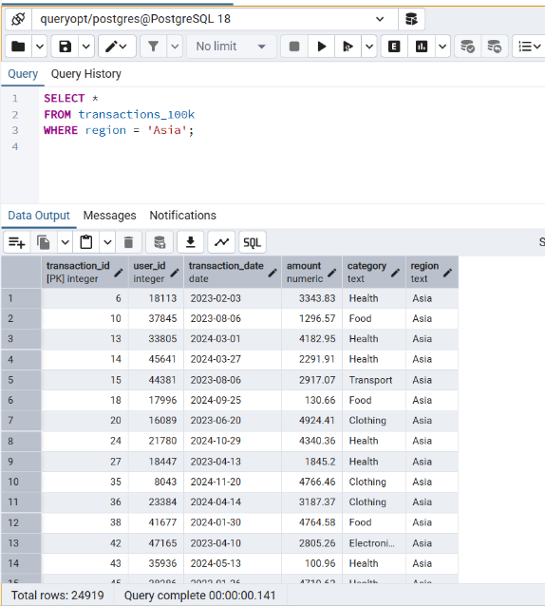PostgreSQL (100k) Q1

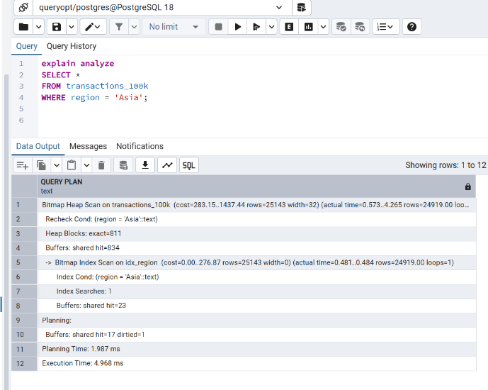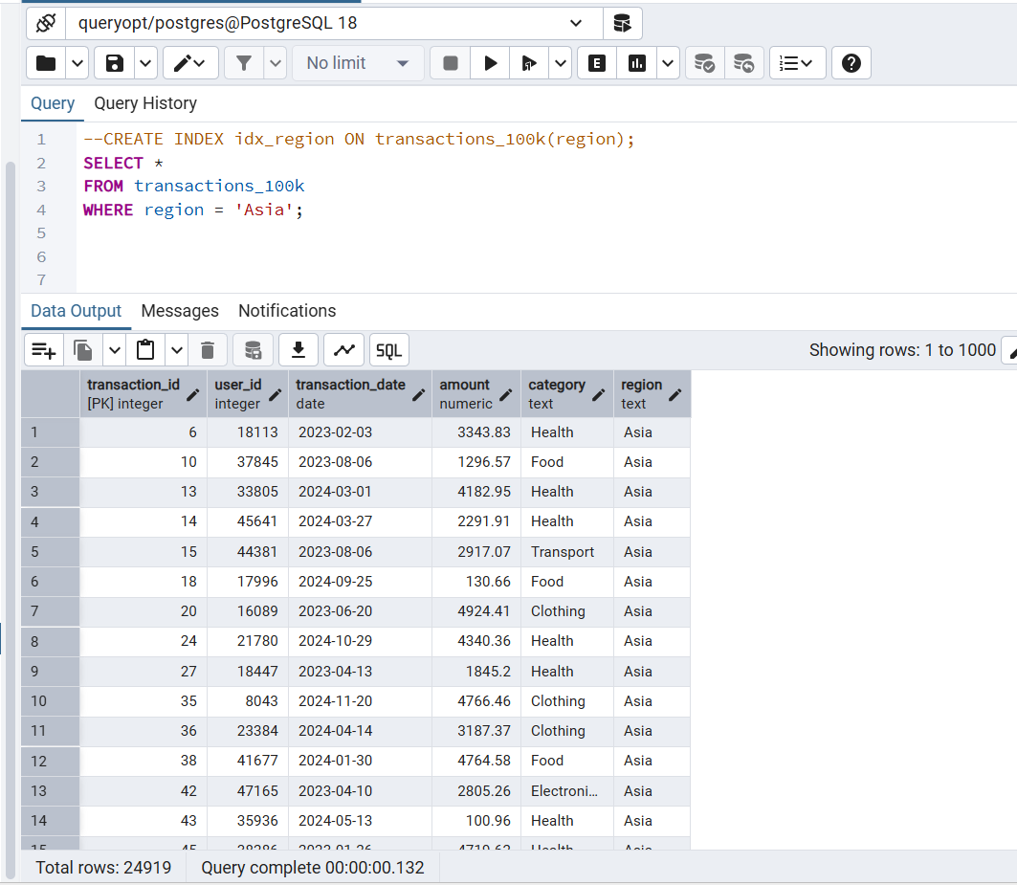

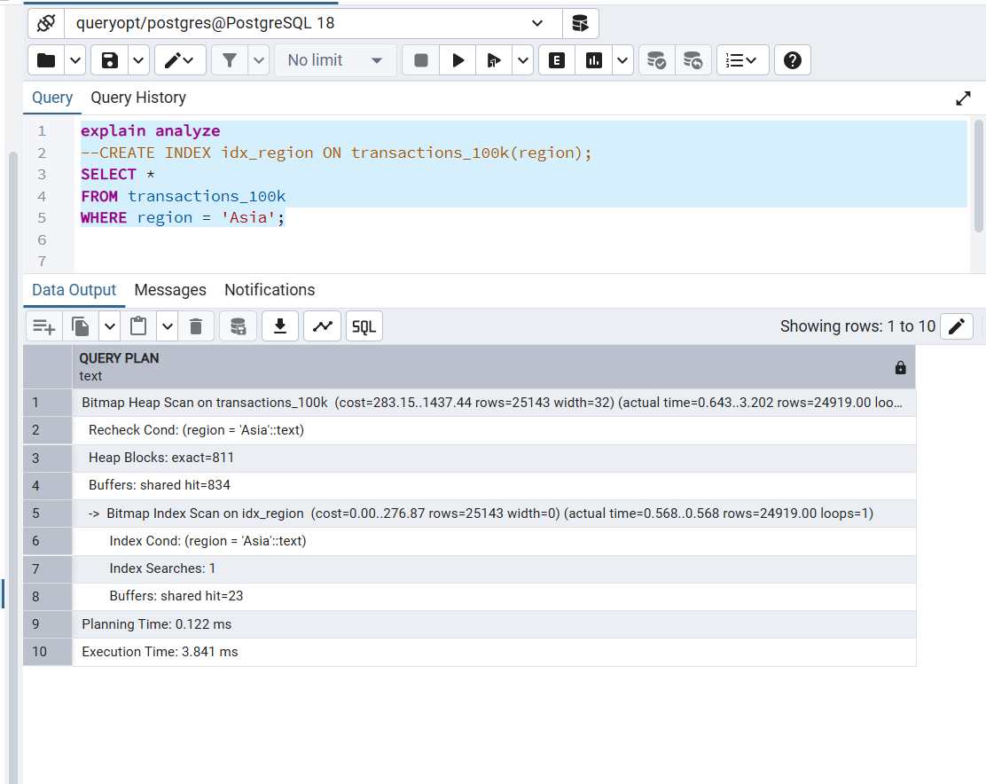

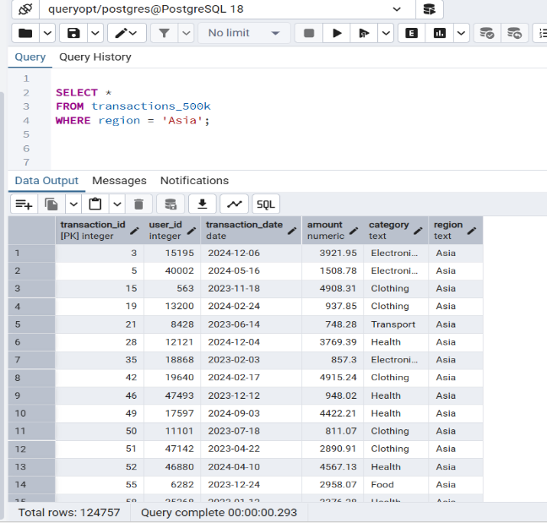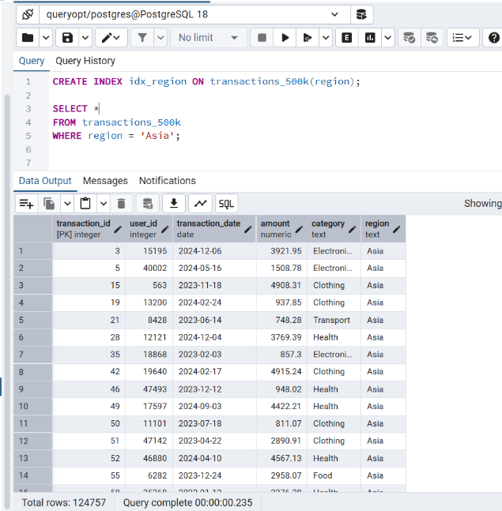PostgreSQL (500k) Q1

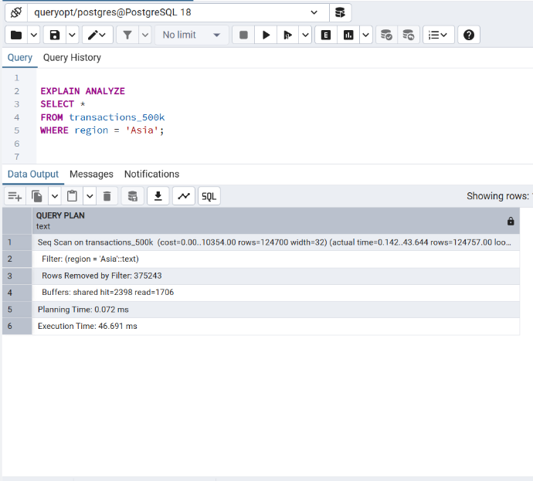

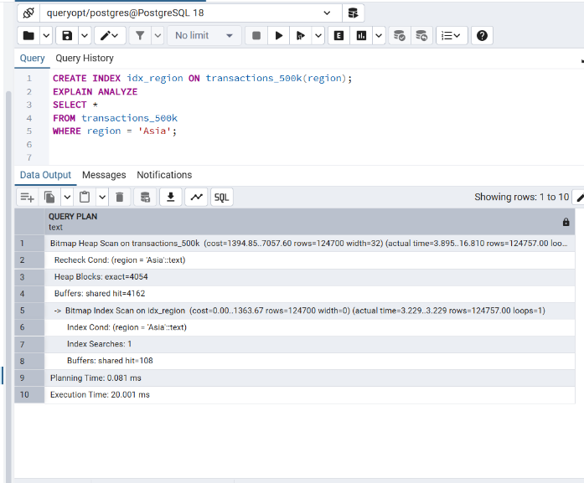

PostgreSQL (1000K) Q1

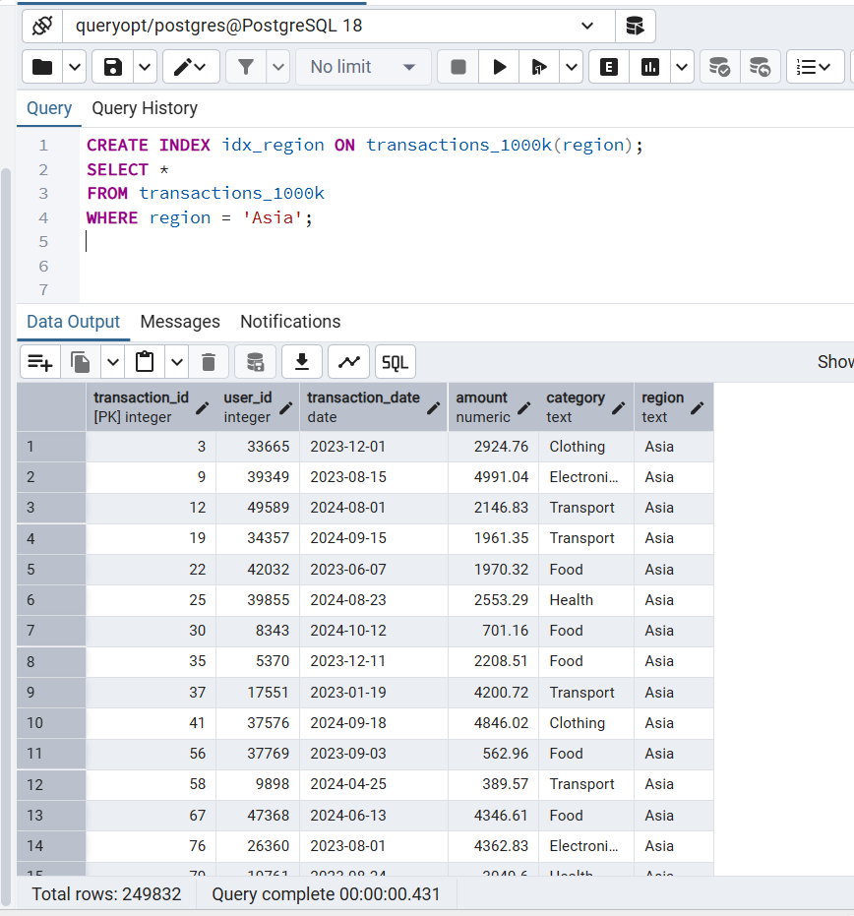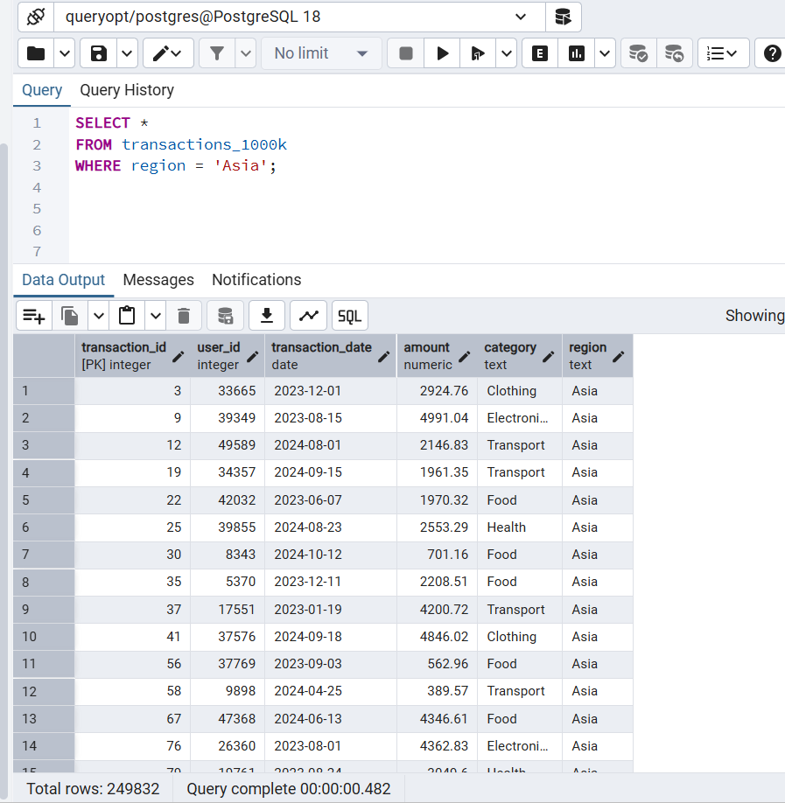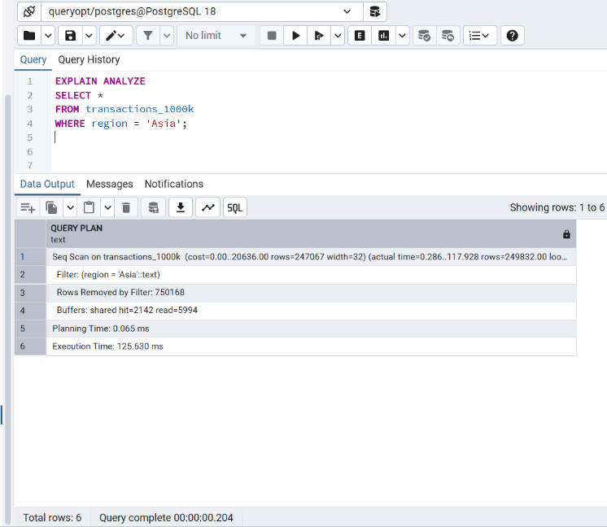

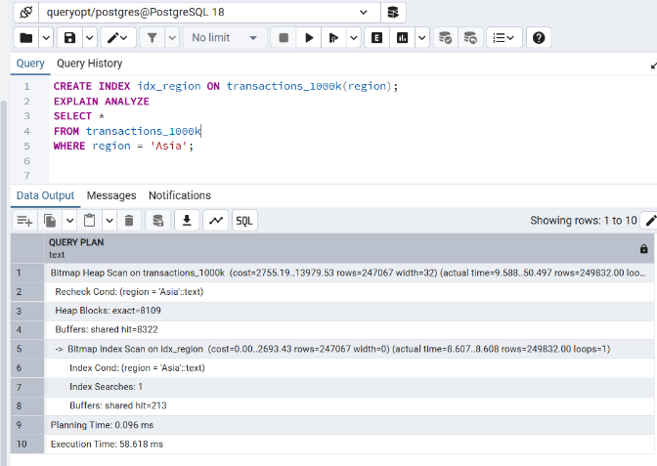

PostgreSQL (100k) Q2

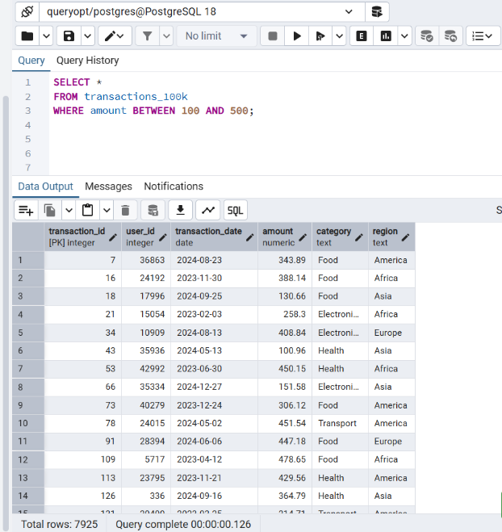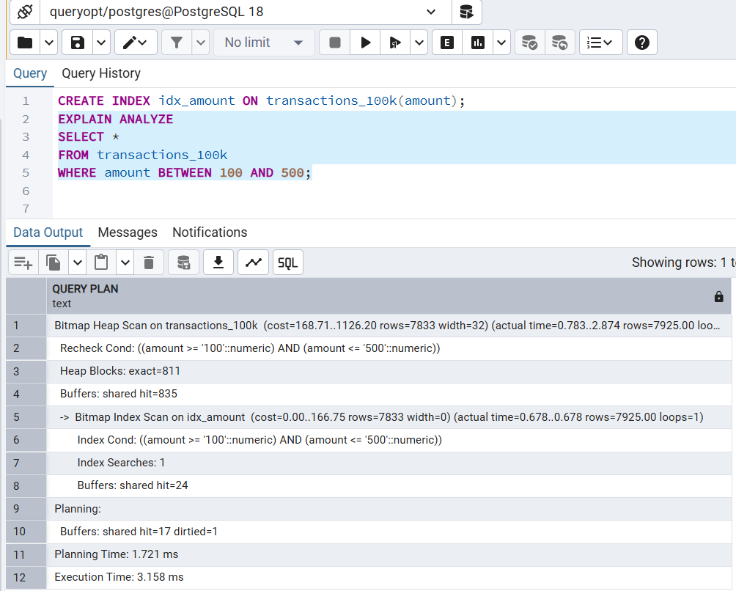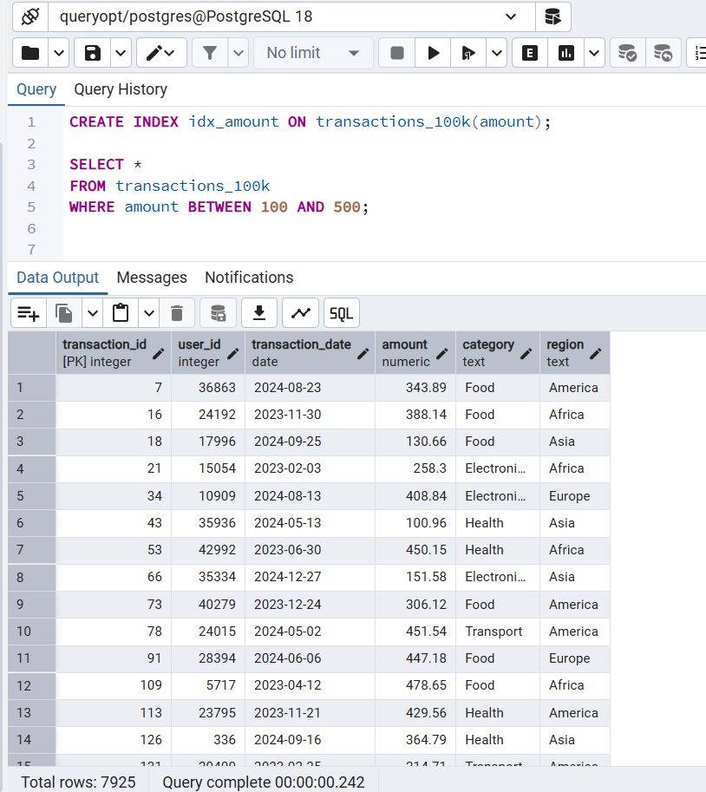

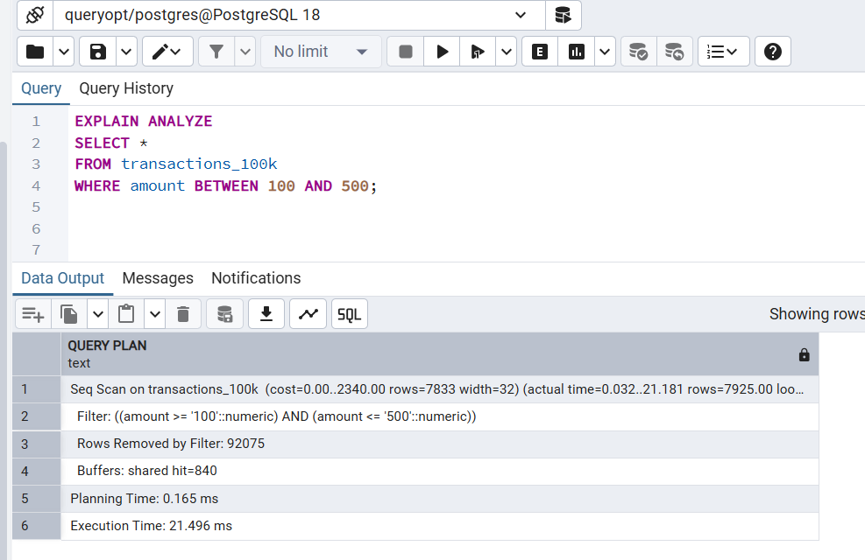

PostgreSQL (500k) Q2

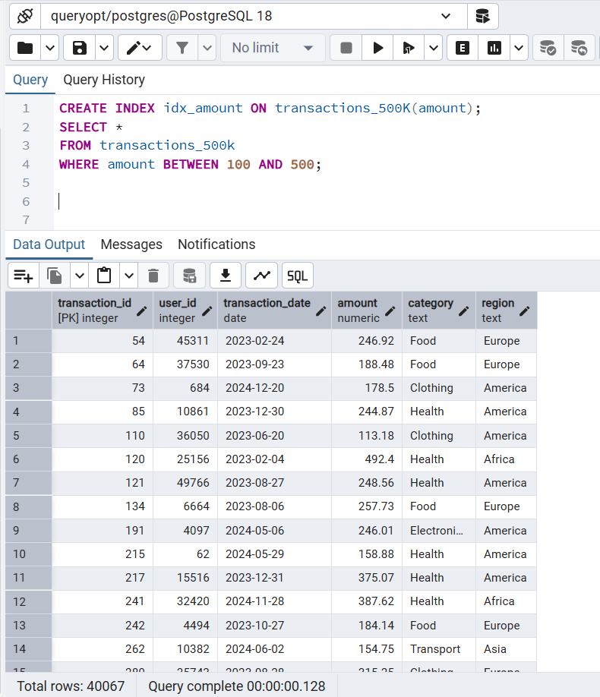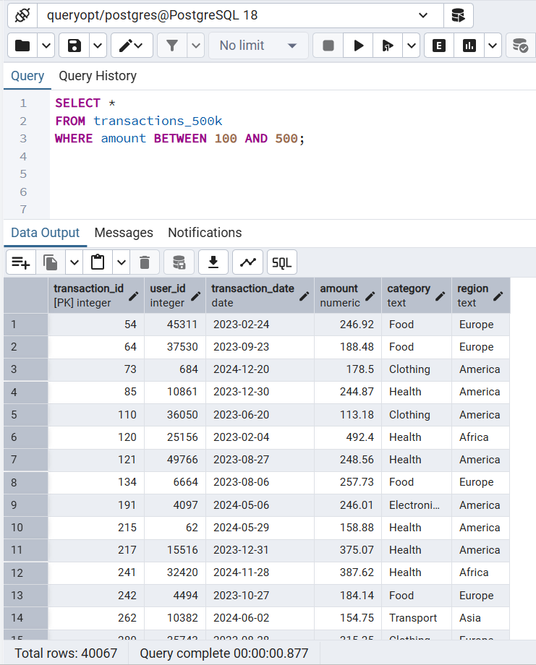

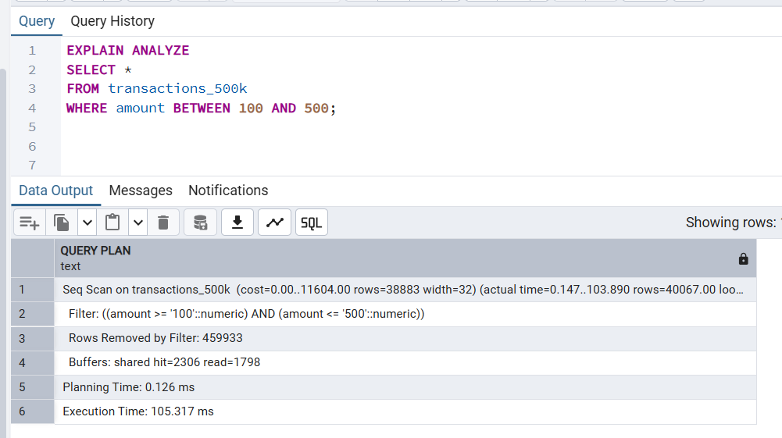 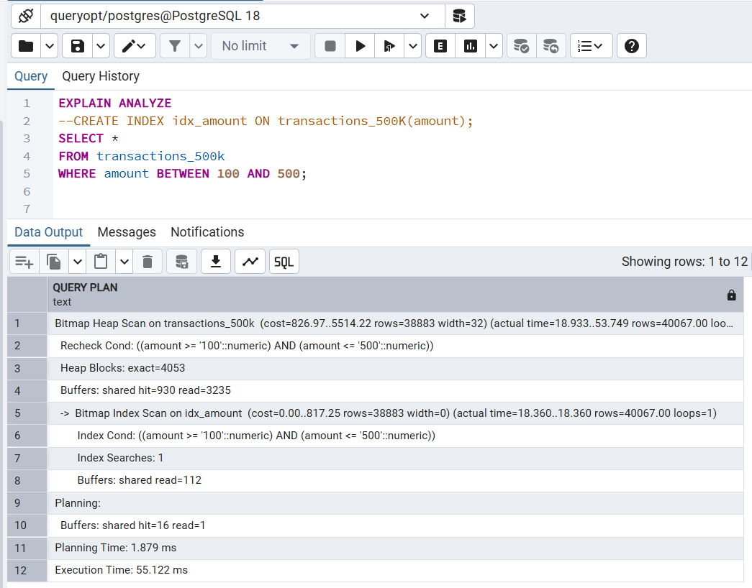

PostgreSQL (1000K) Q2

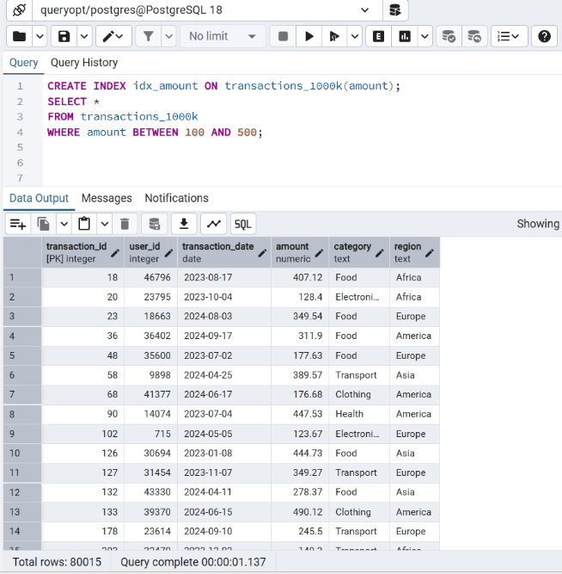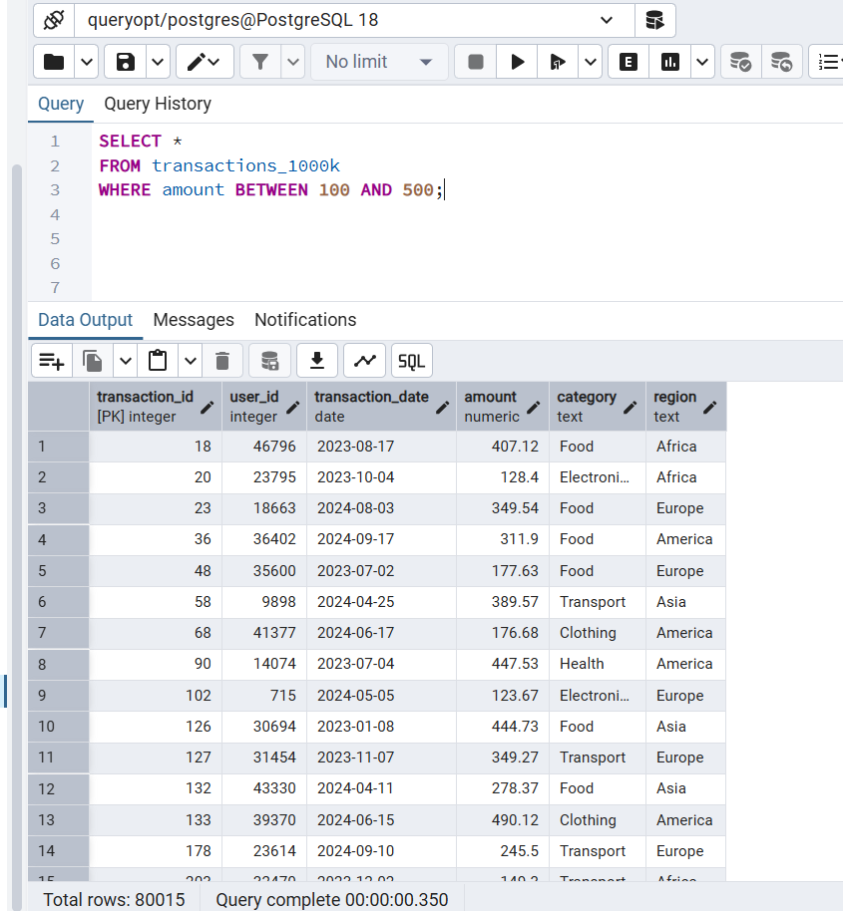

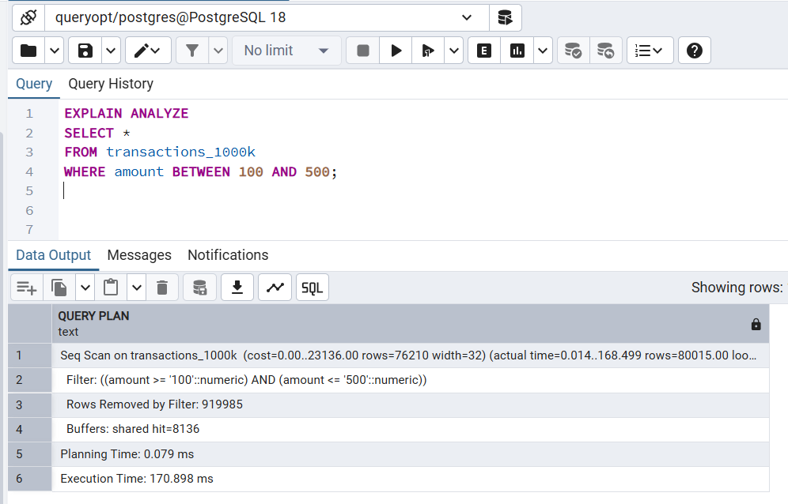 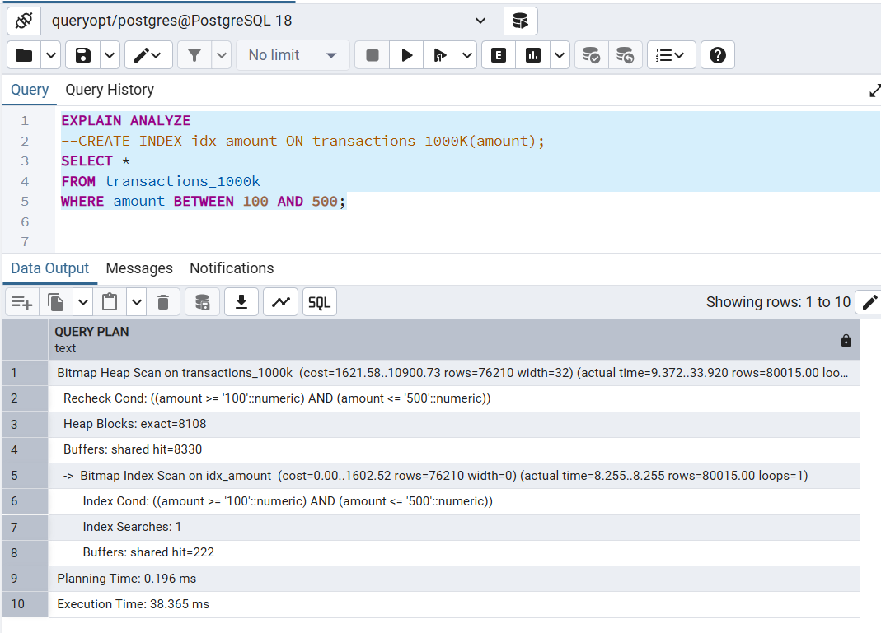

PostgreSQL (100K) Q3

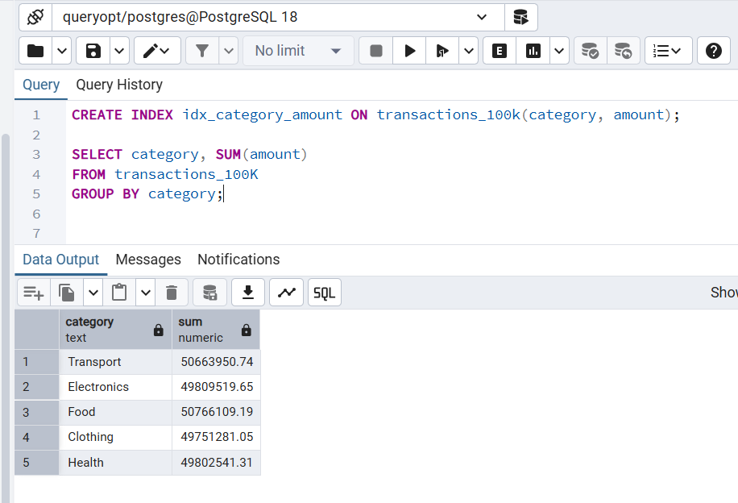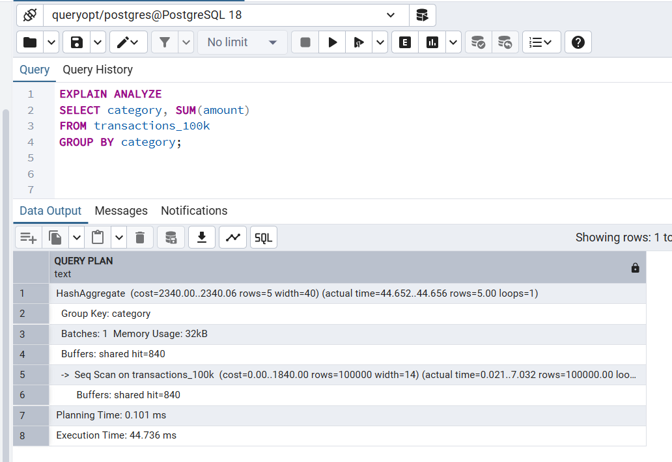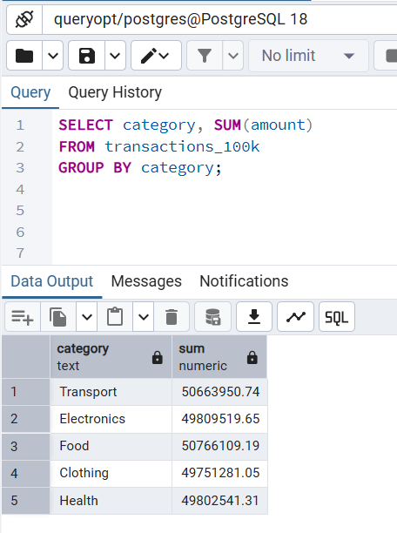

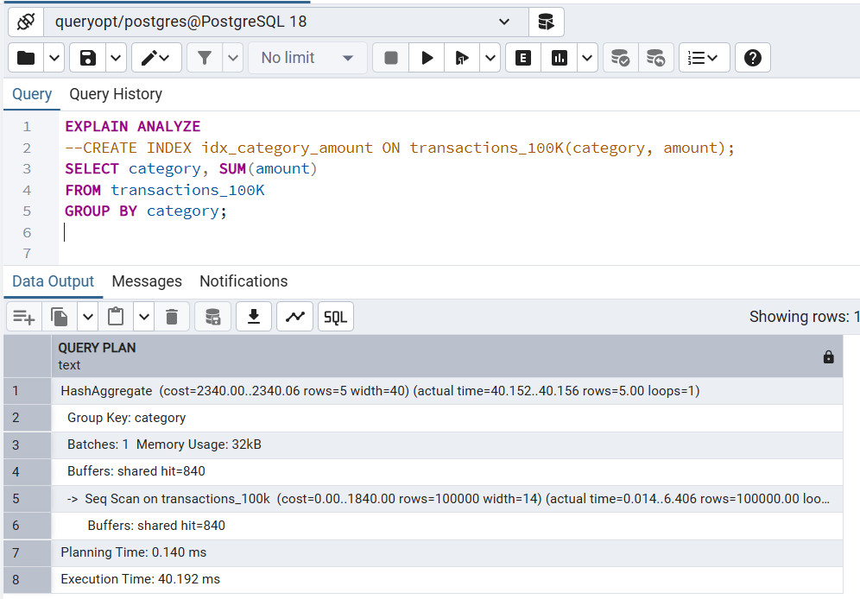

PostgreSQL (500K) Q3

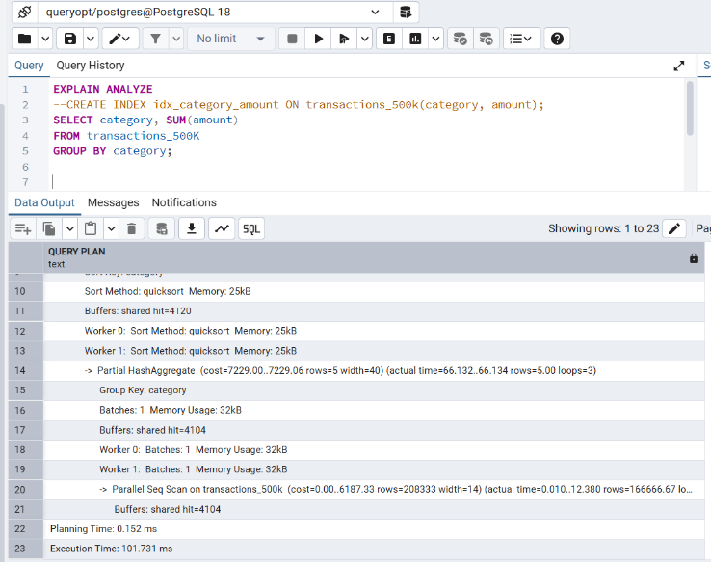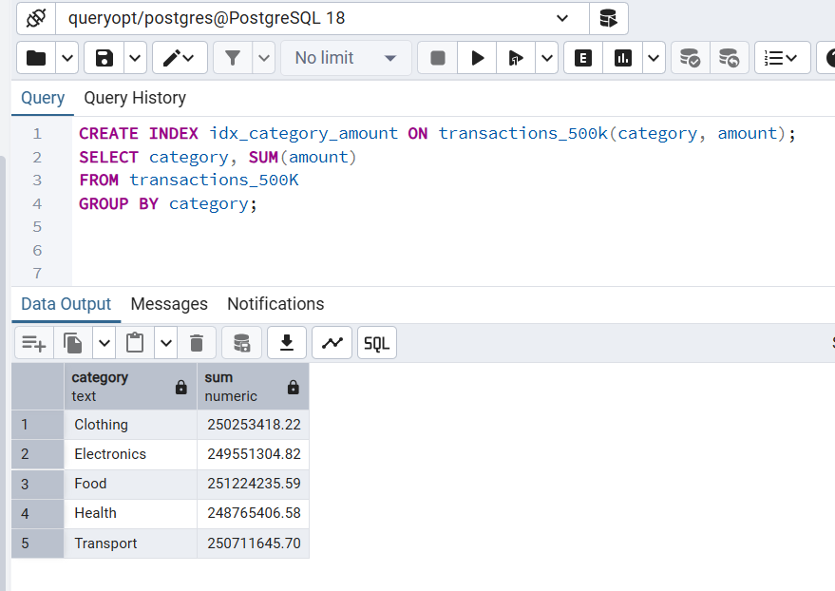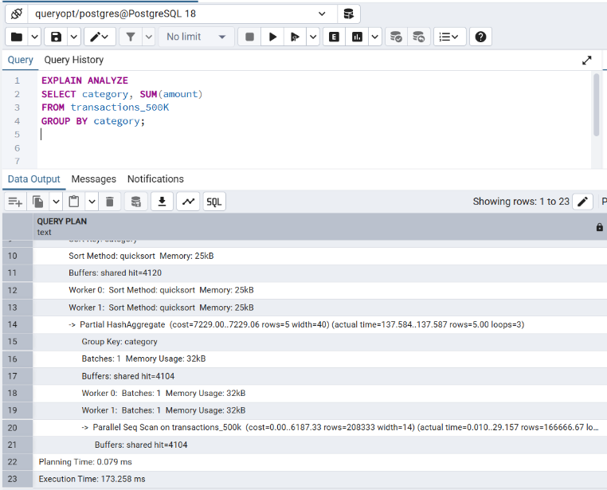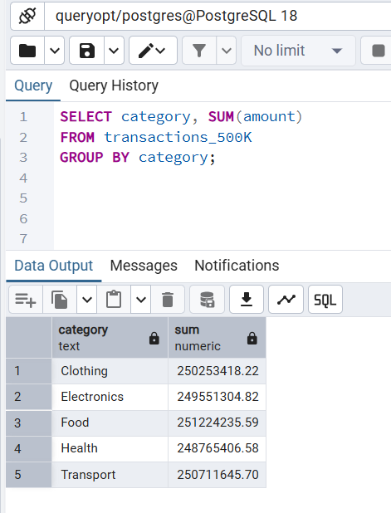

PostgreSQL (1000K) Q3

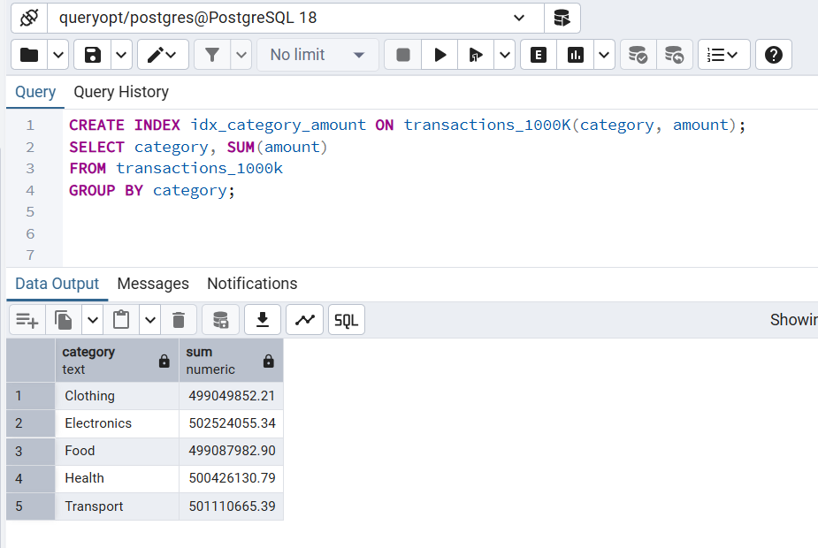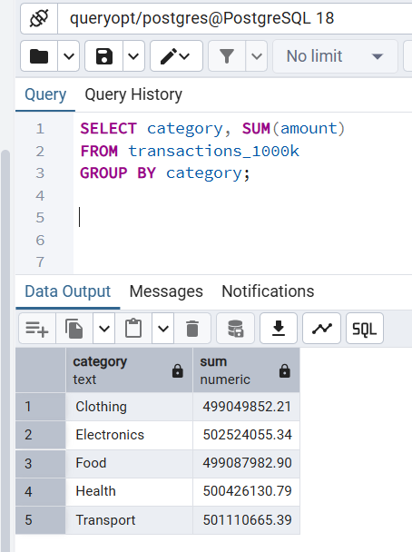

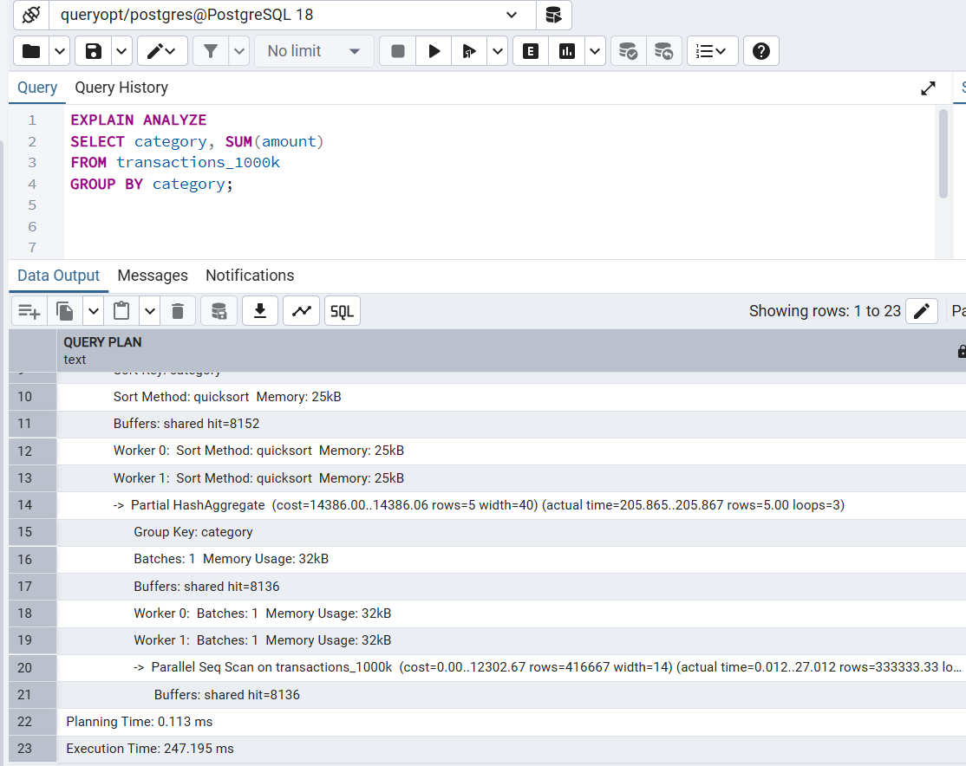 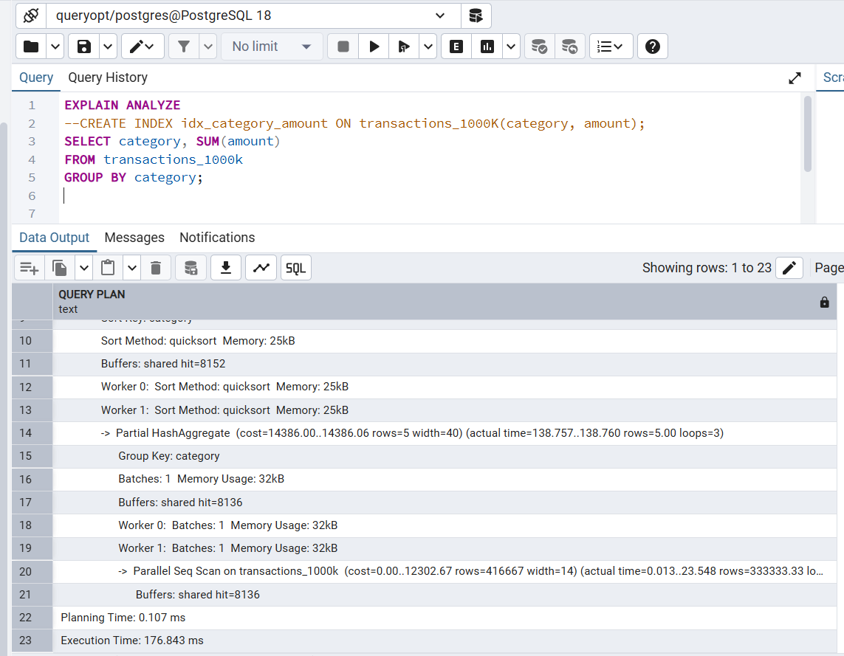

PostgreSQL 100K Q4

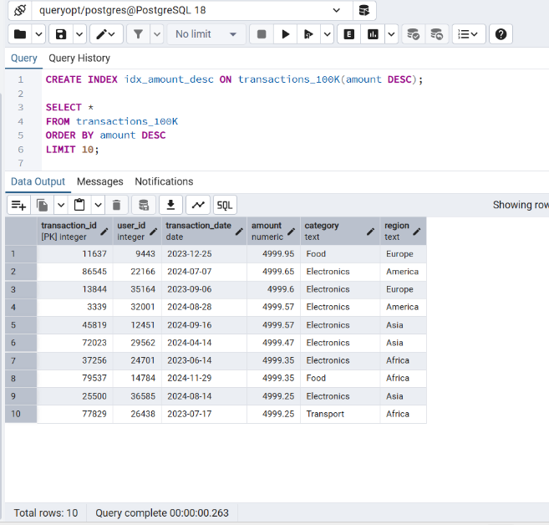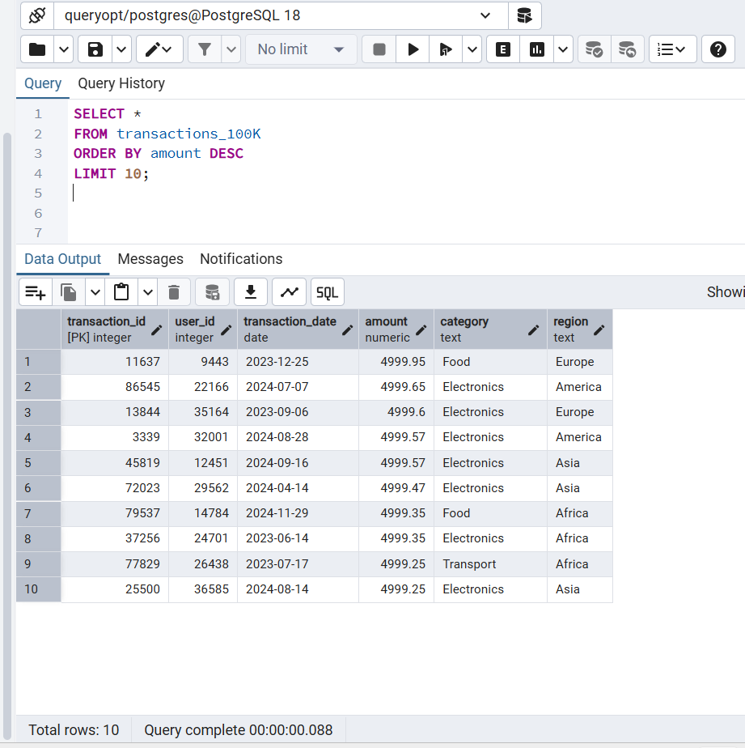

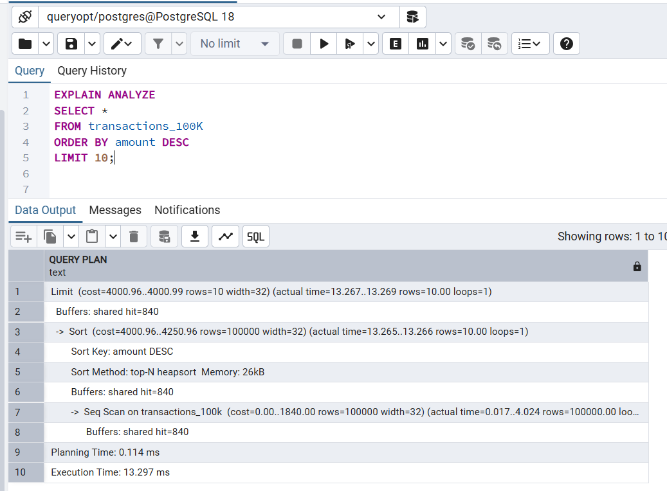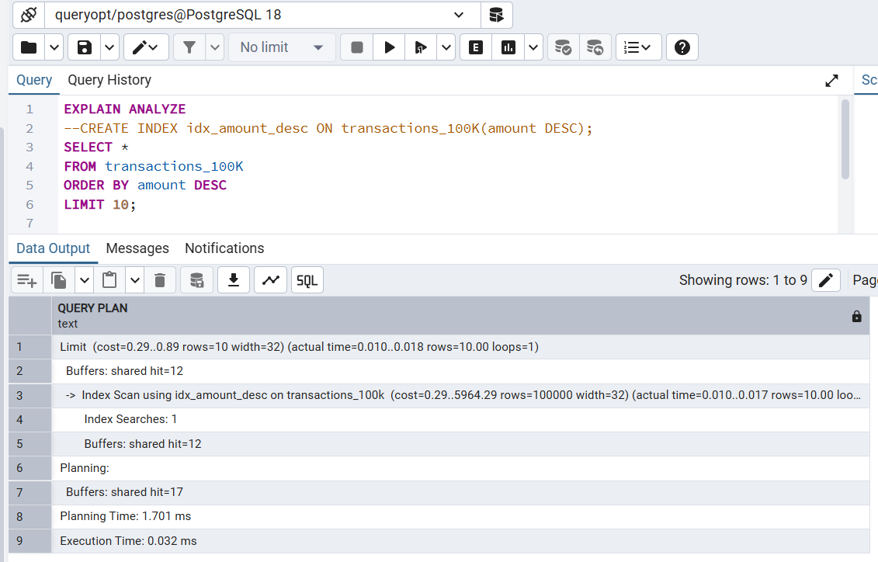

PostgreSQL 500K Q4

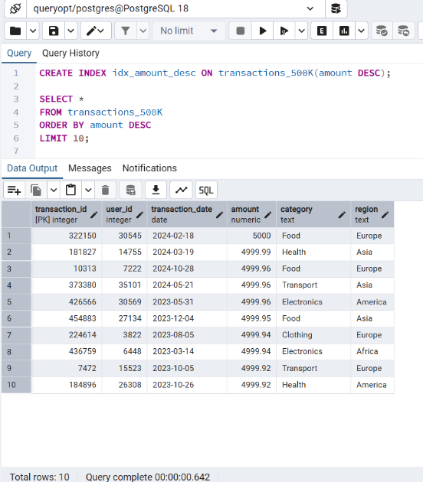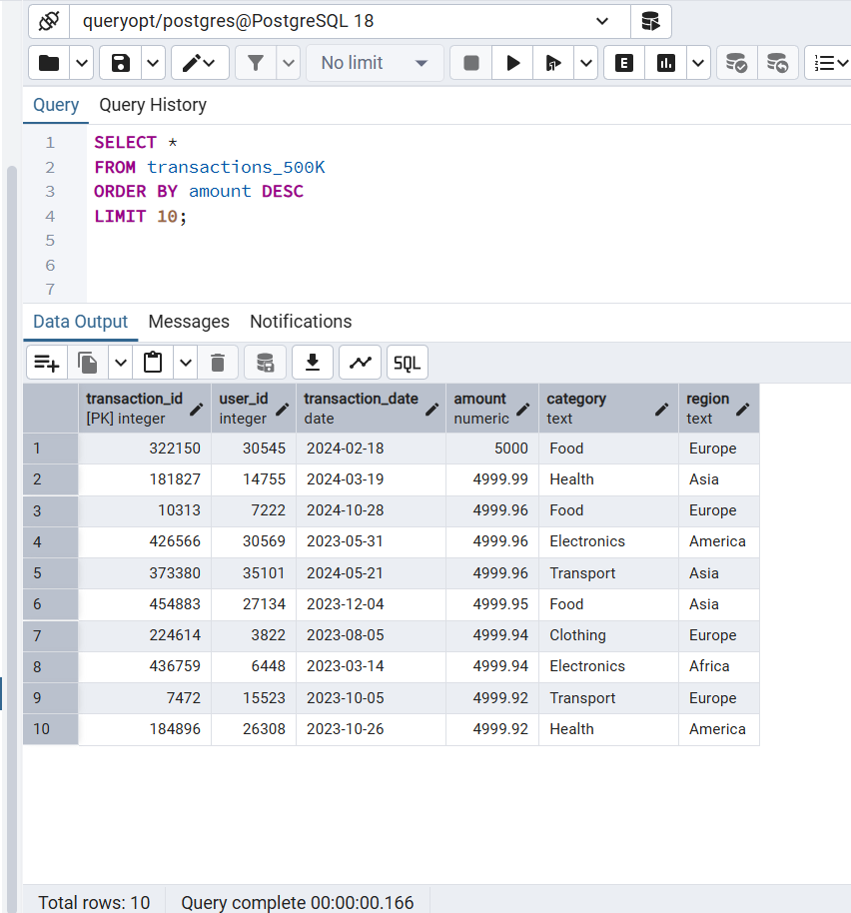

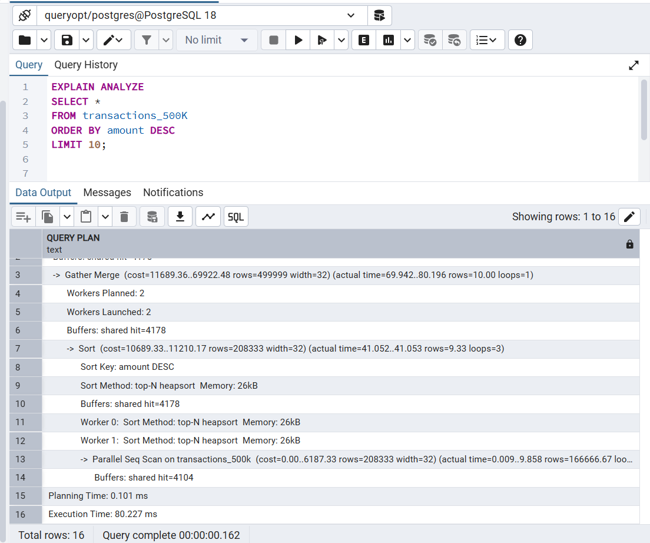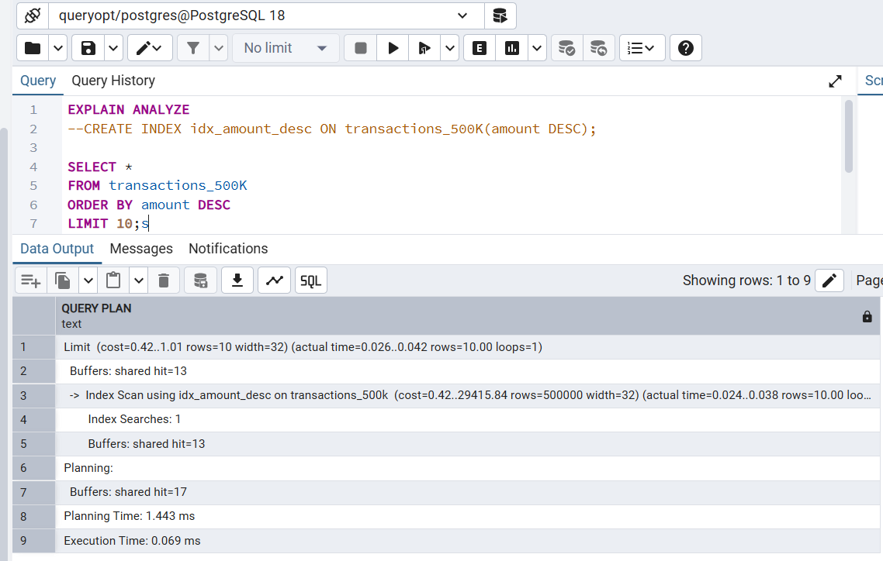

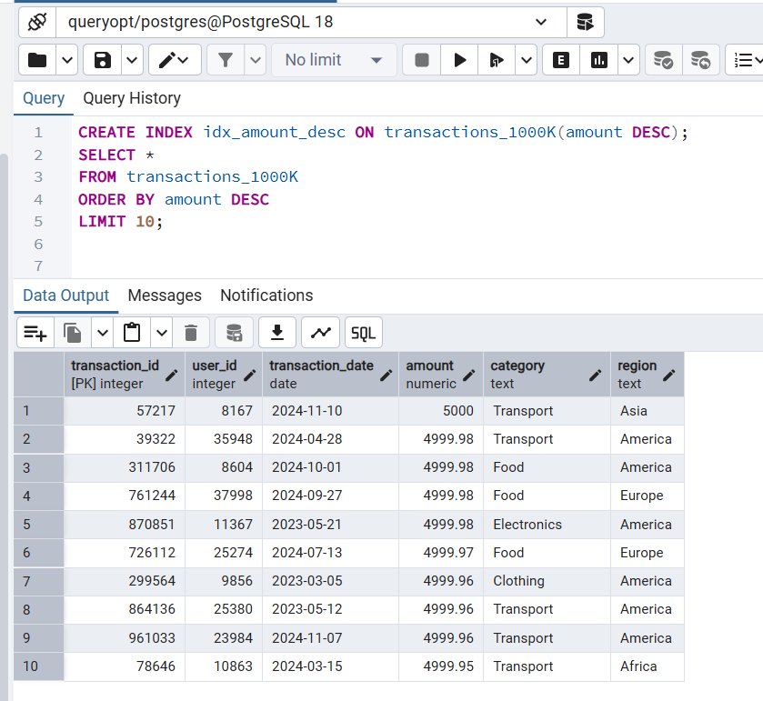PostgreSQL 1000K Q4

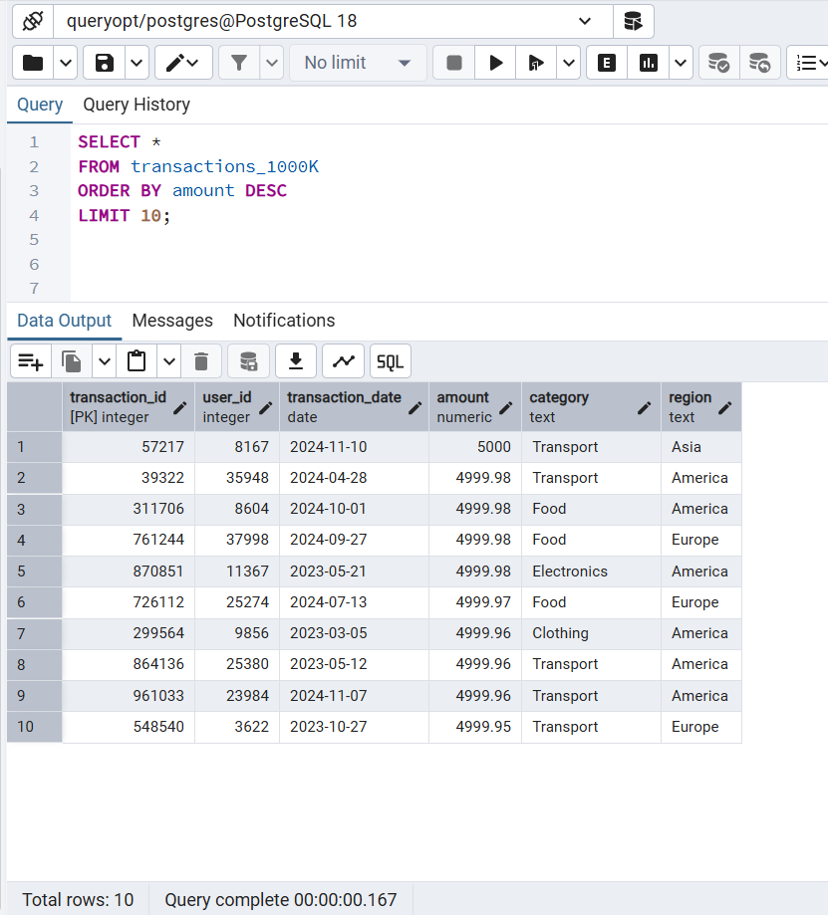

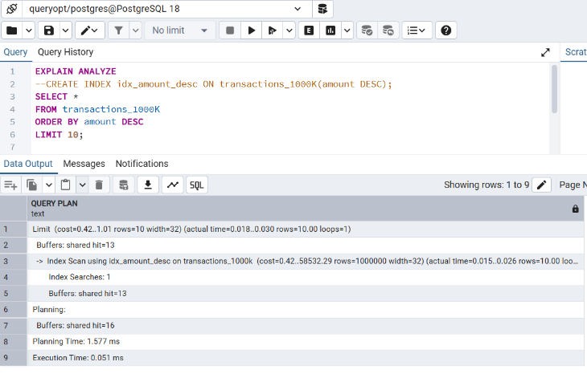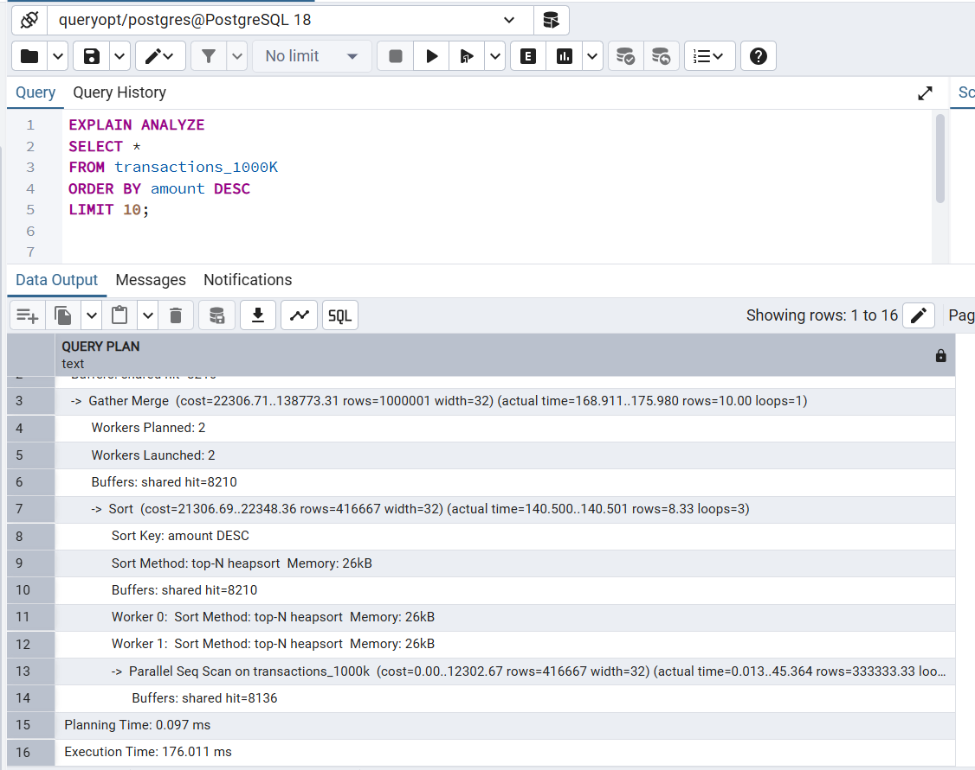

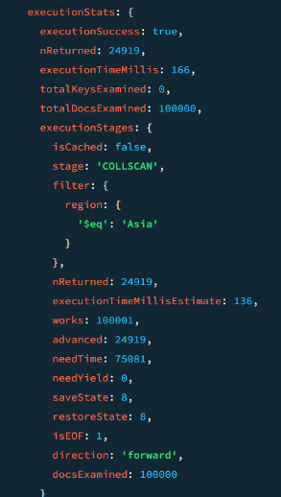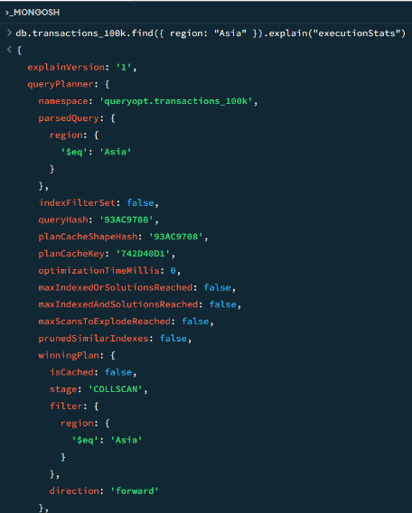MongoDB 100K Q1

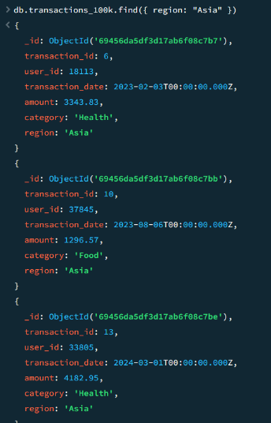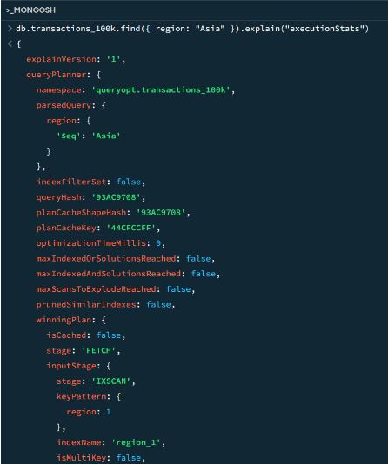

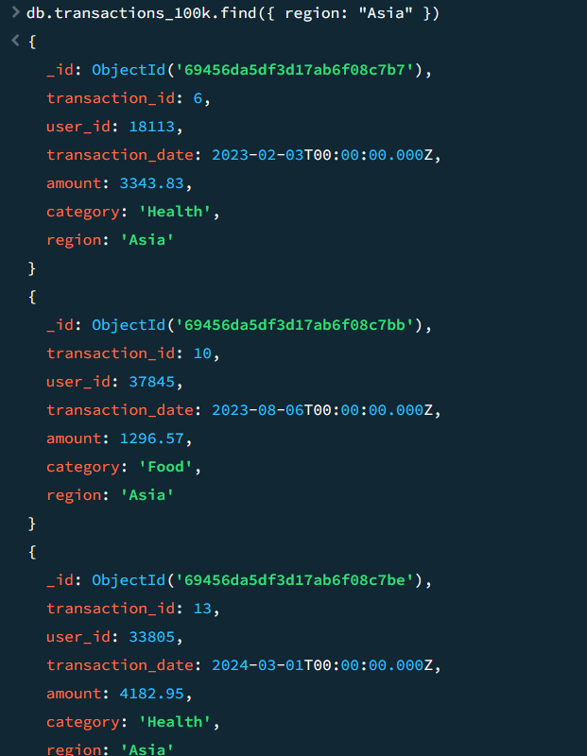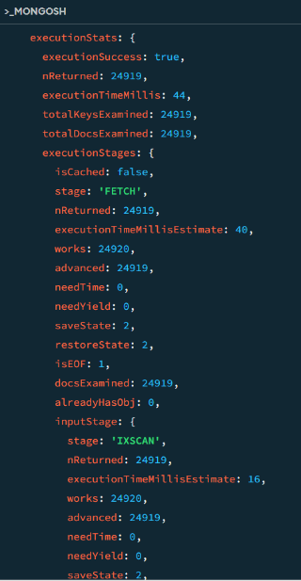

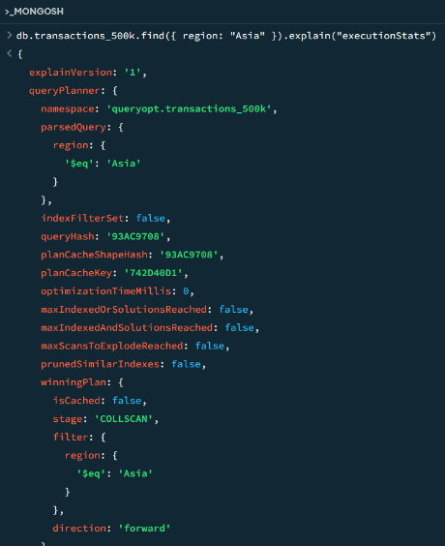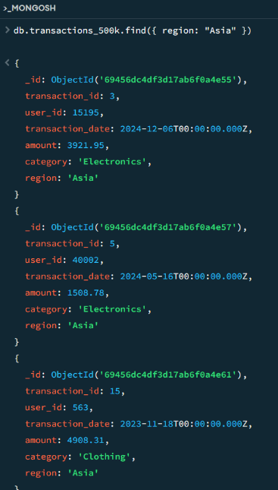MongoDB 500K Q1

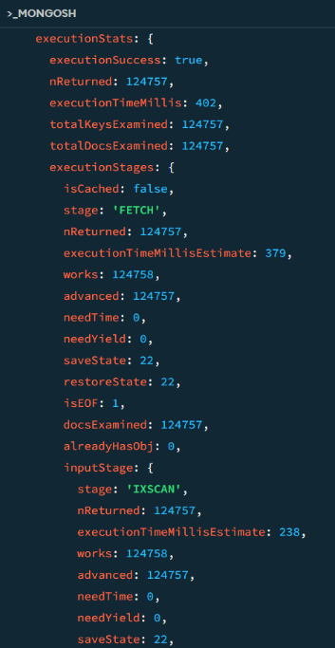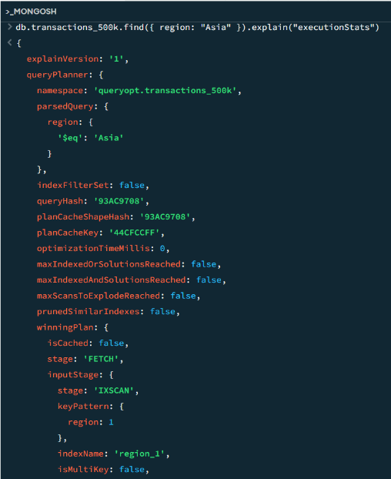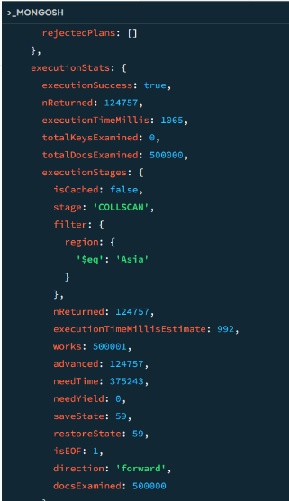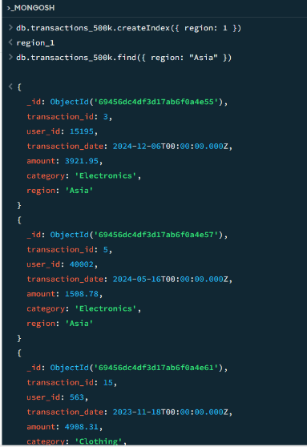

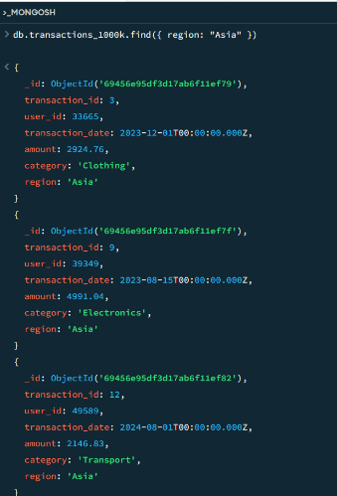MongoDB 1000K Q1

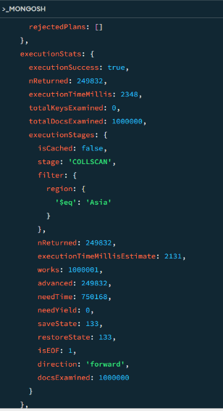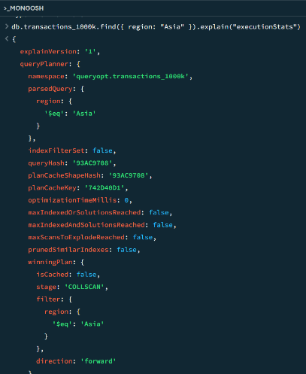

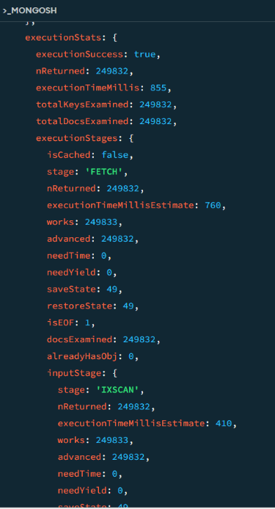

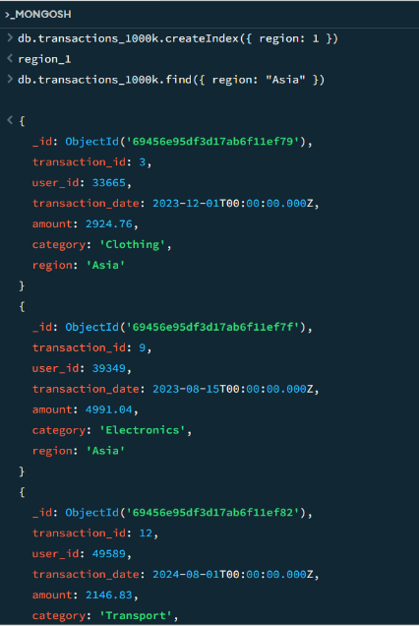

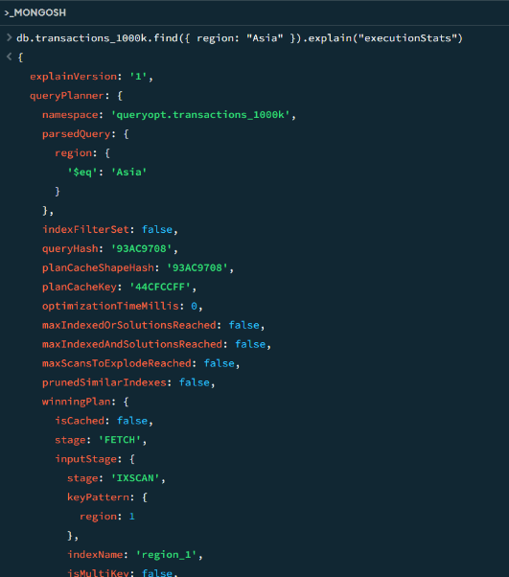

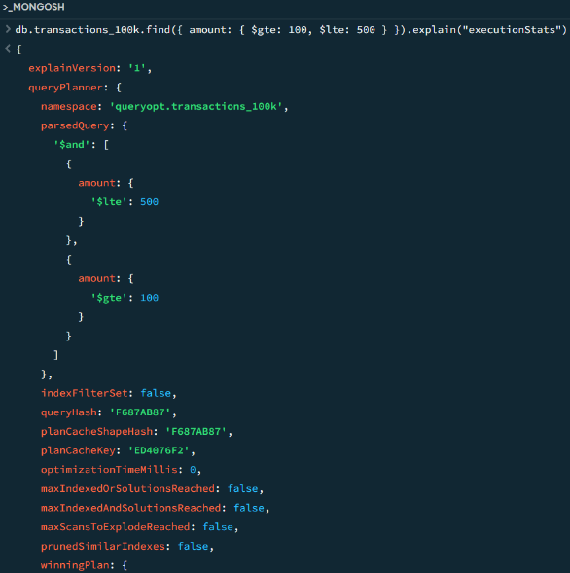MongoDB 100K Q2

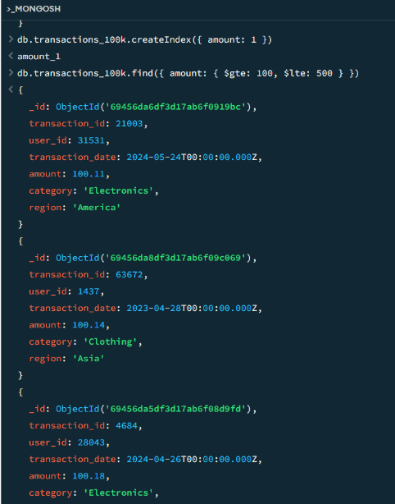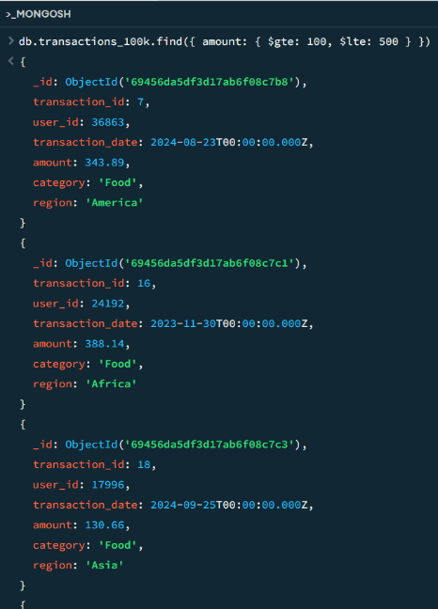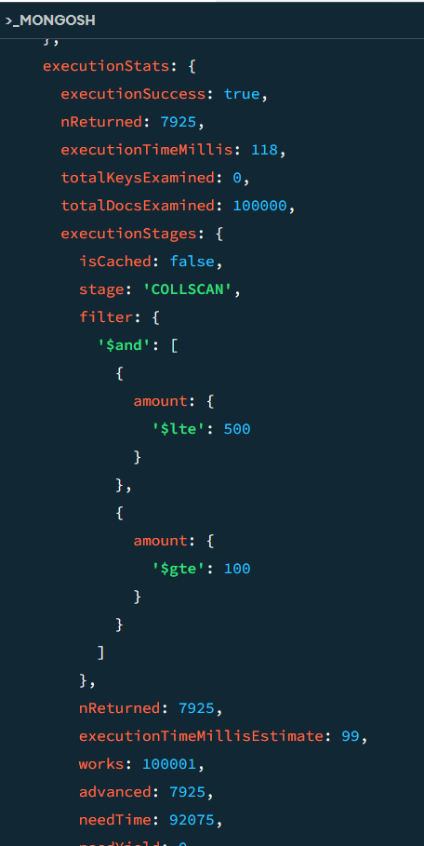

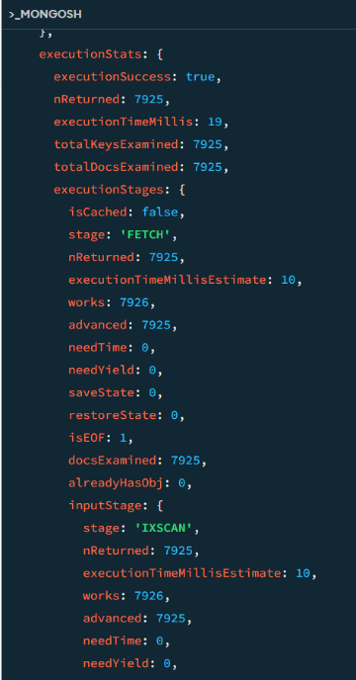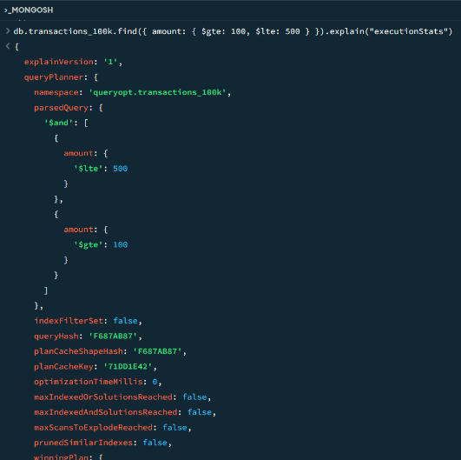

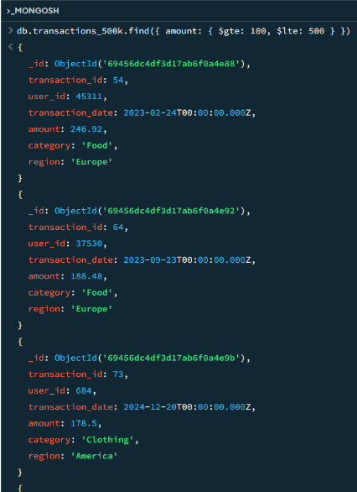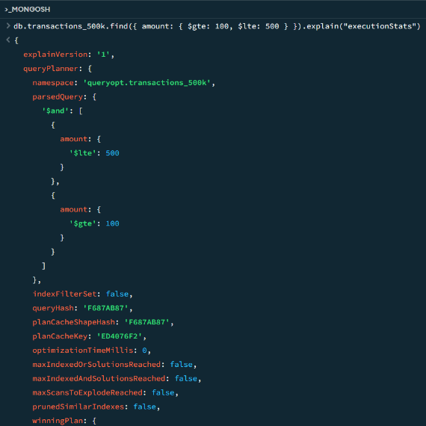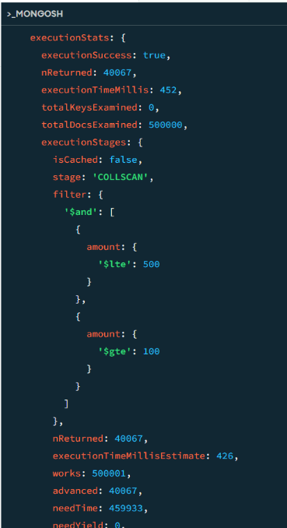MongoDB 500K Q2

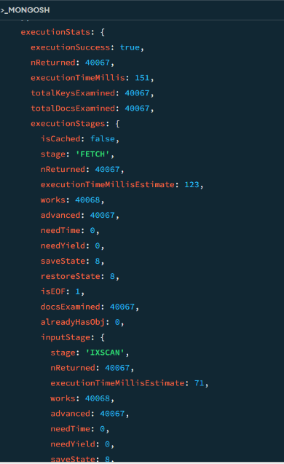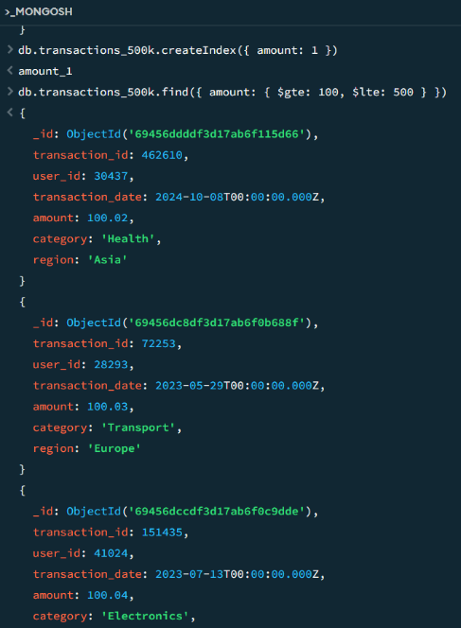

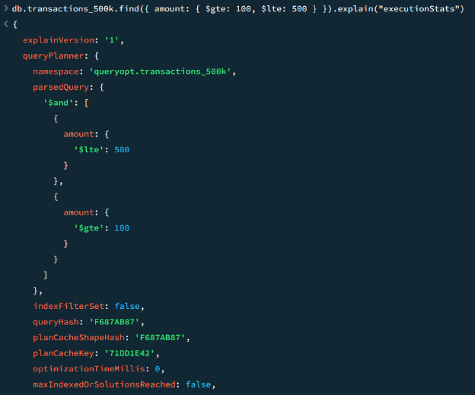

MongoDB 1000K Q2

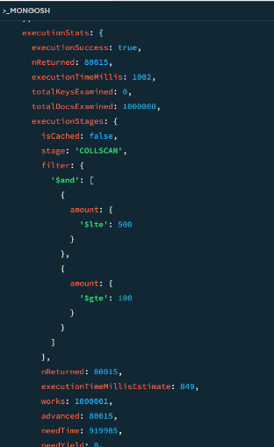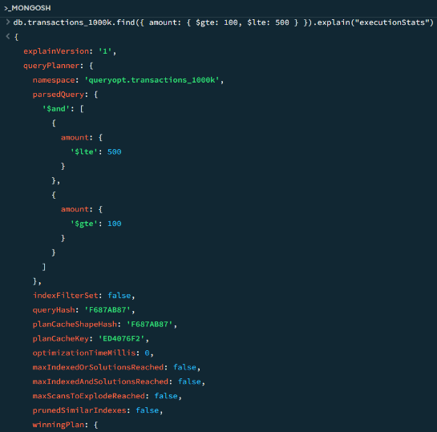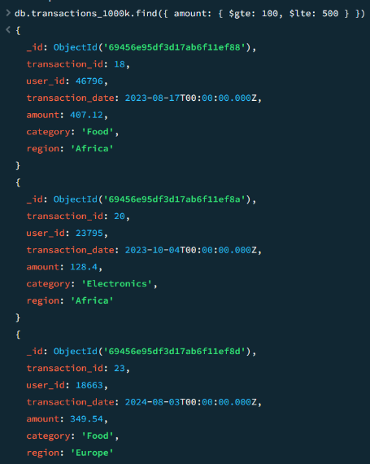

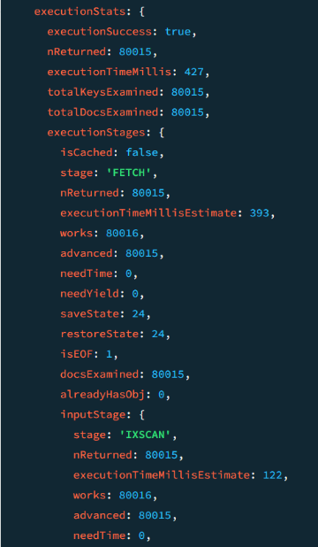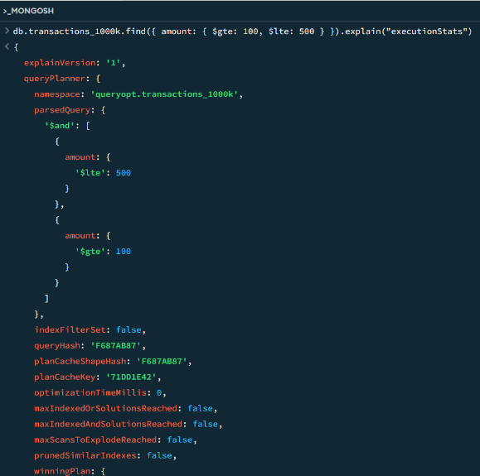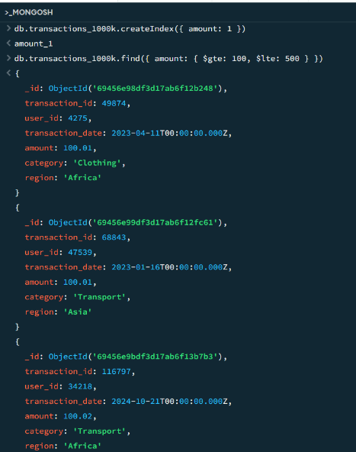

MongoDB 100K Q3

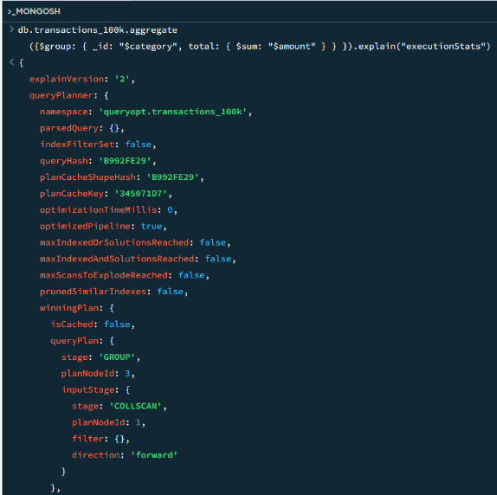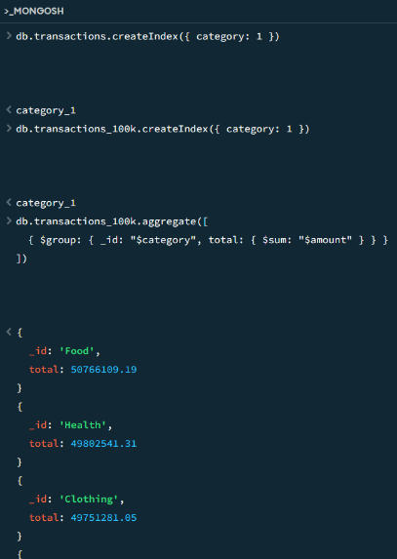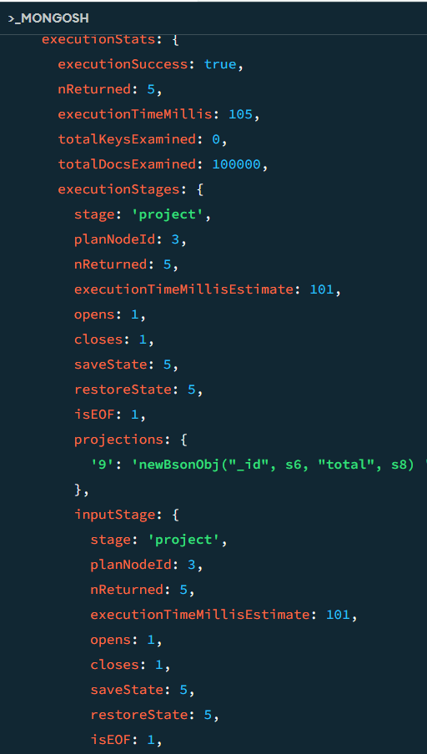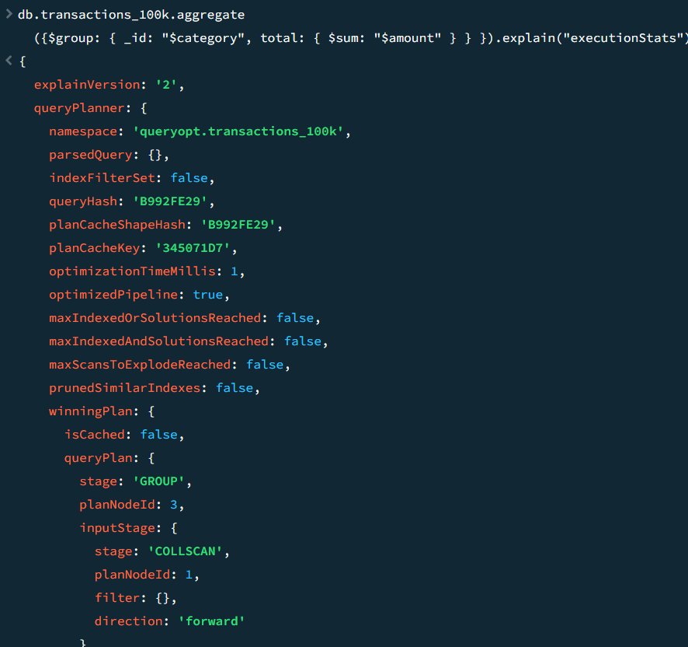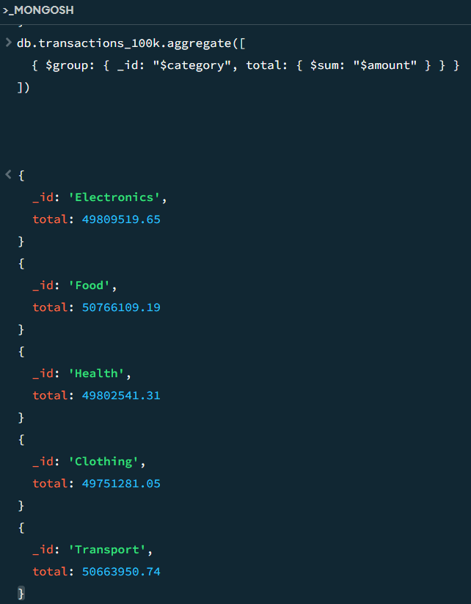

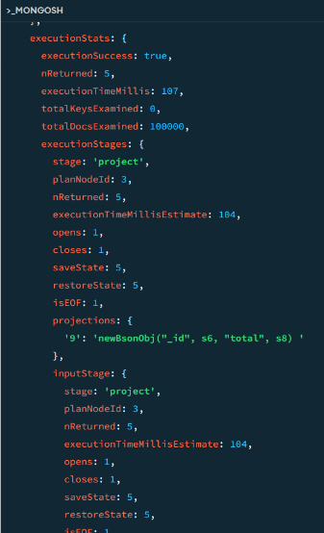

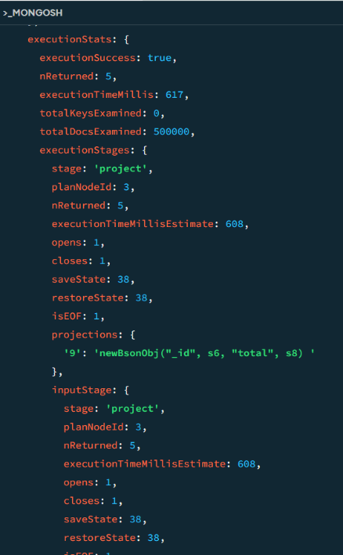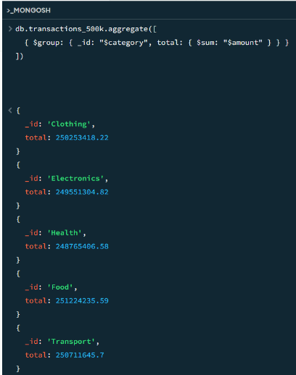MongoDB 500K Q3

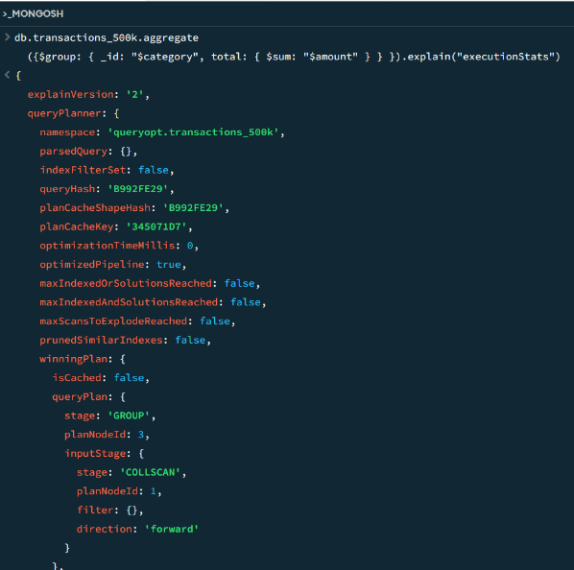

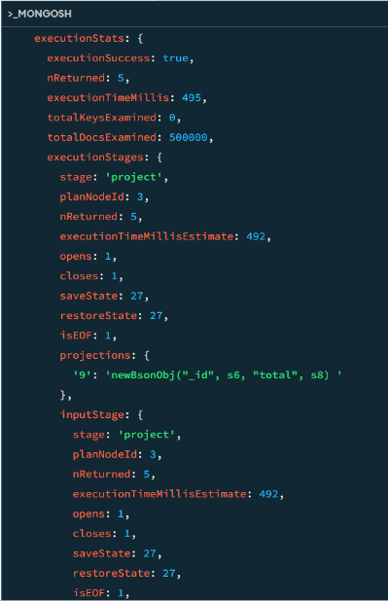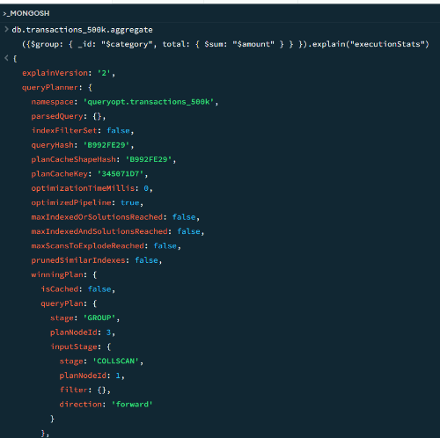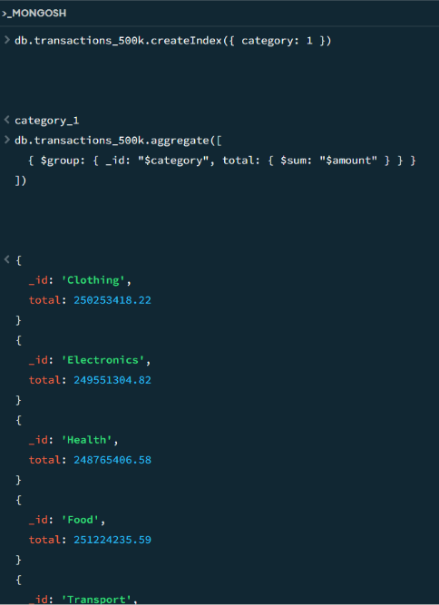

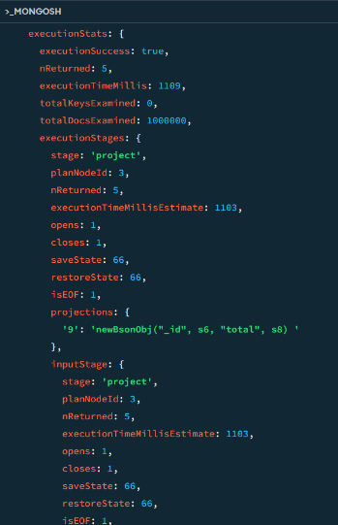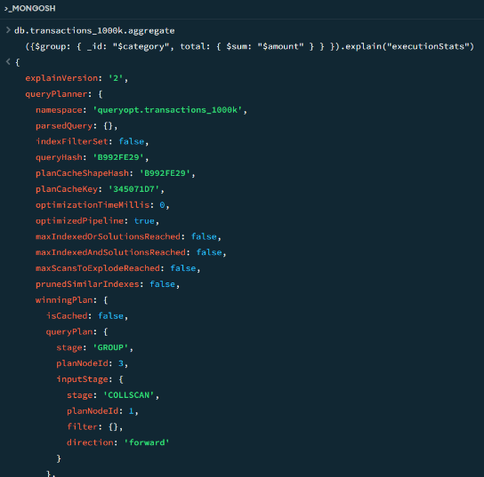MongoDB 1000k Q3

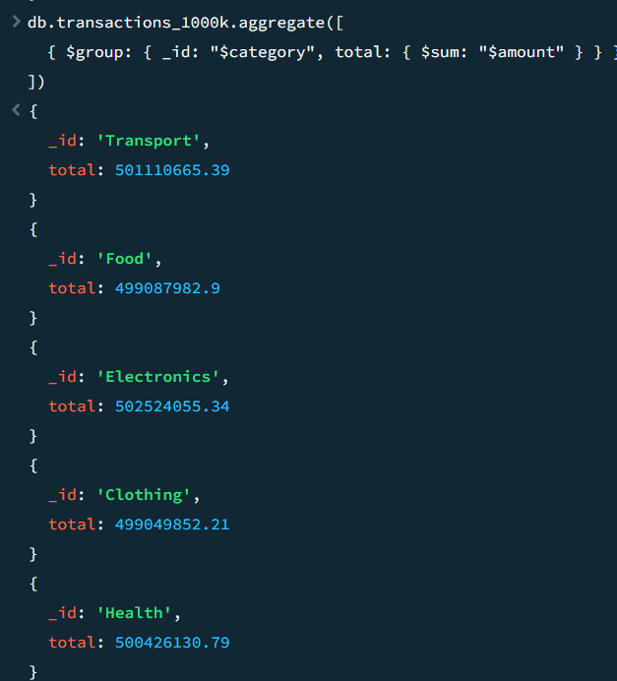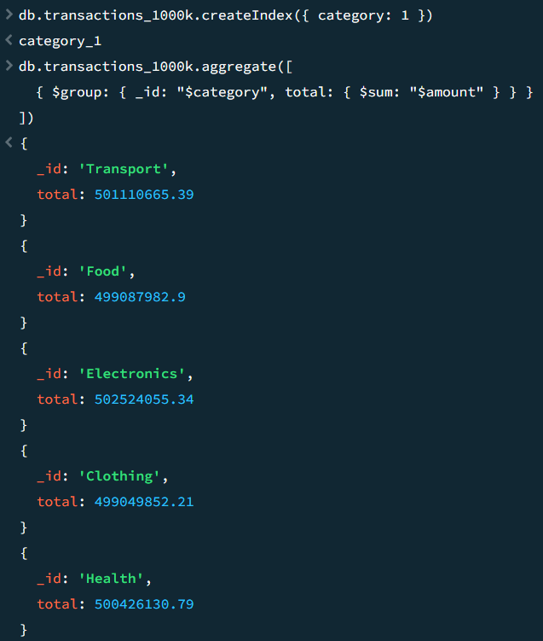

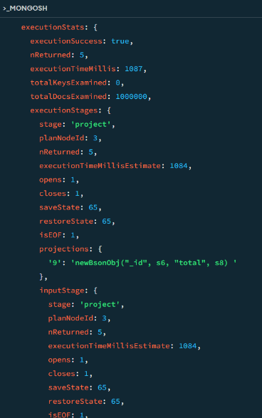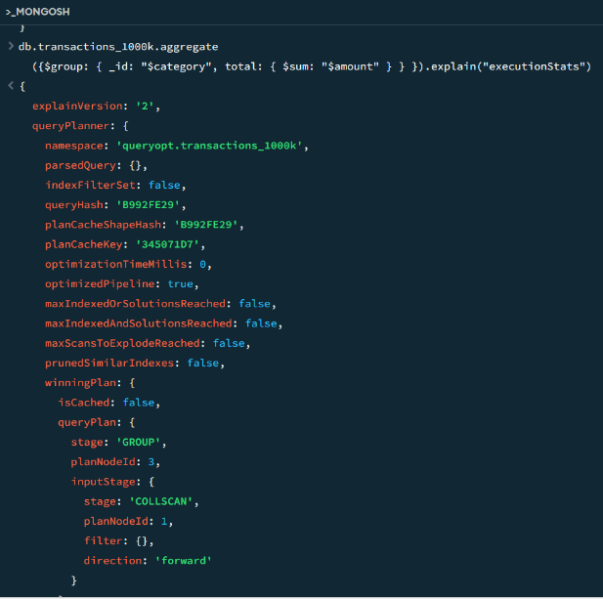

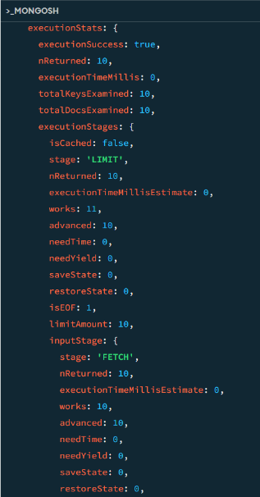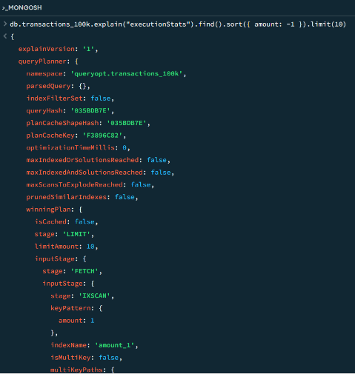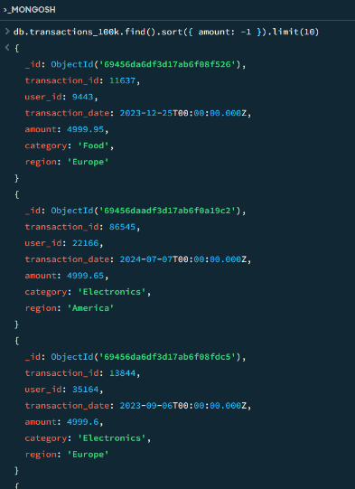MongoDB 100K Q4

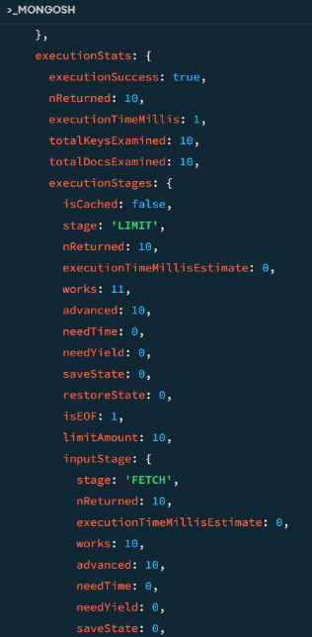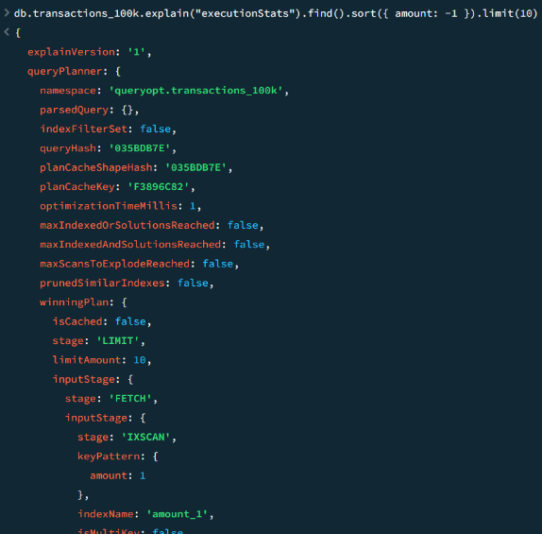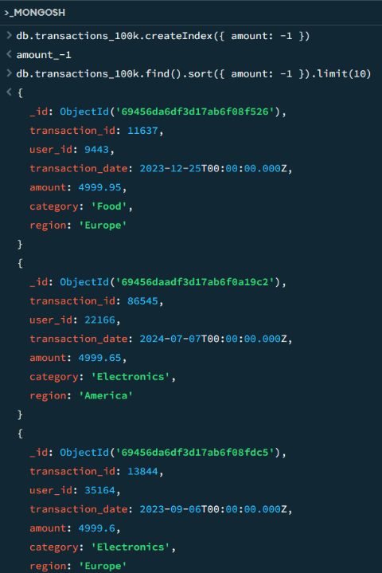

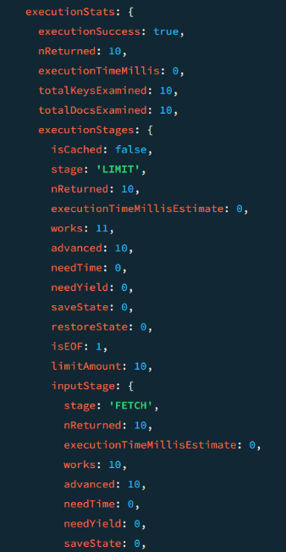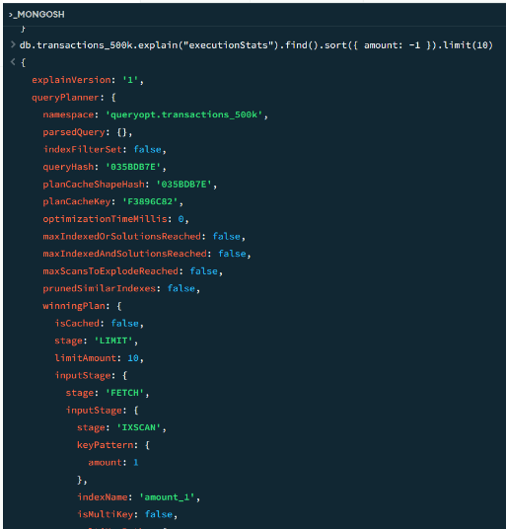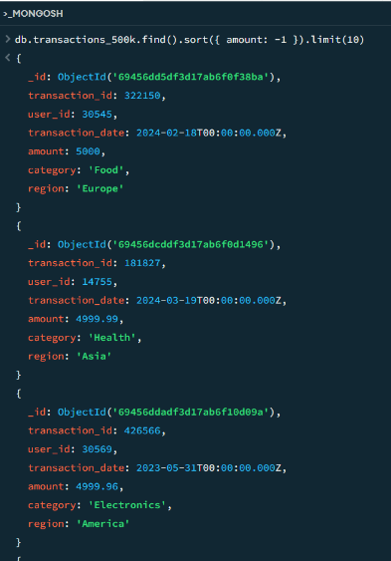MongoDB 500K Q4

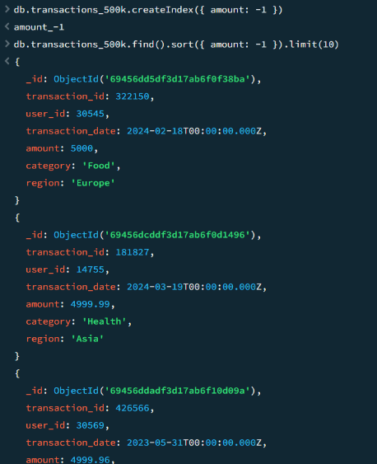

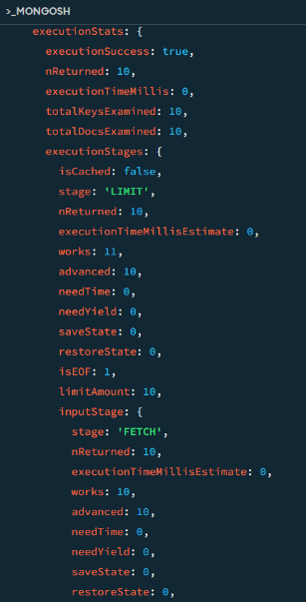

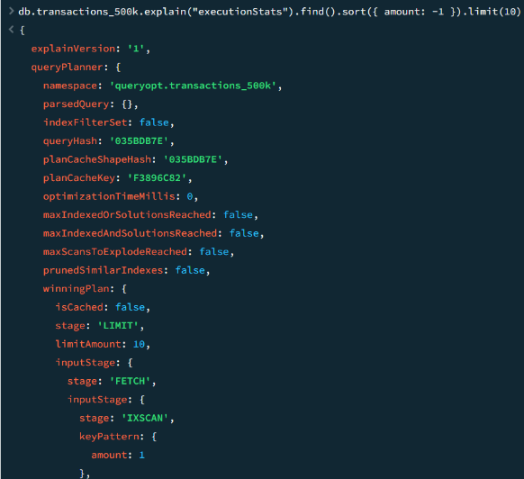

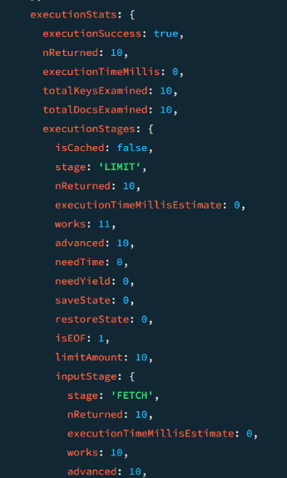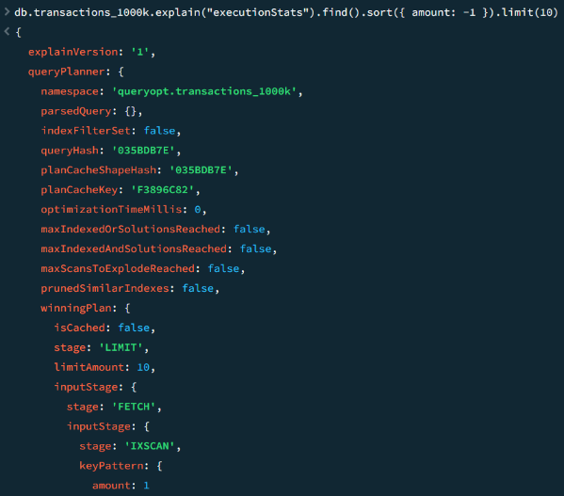MongoDB 1000K Q4

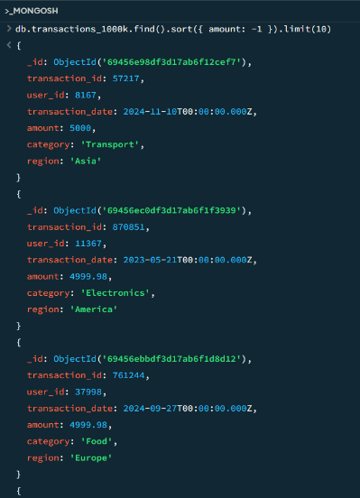

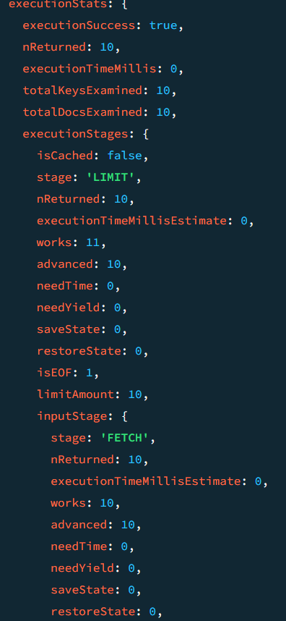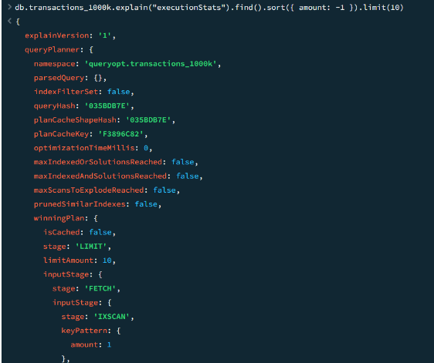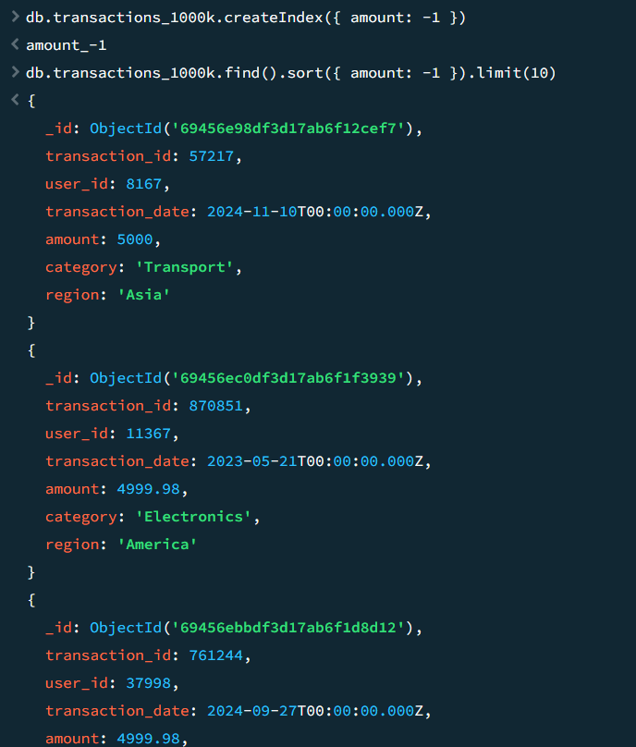

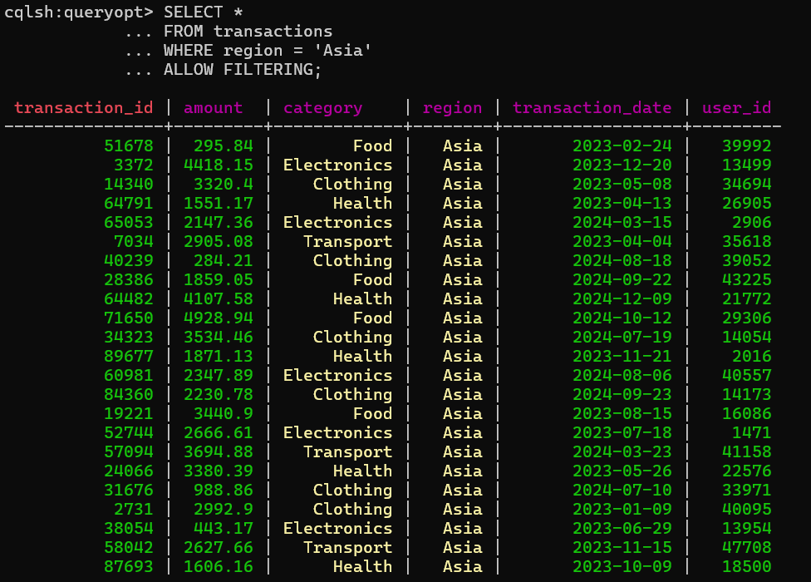Cassandra 100K Q1

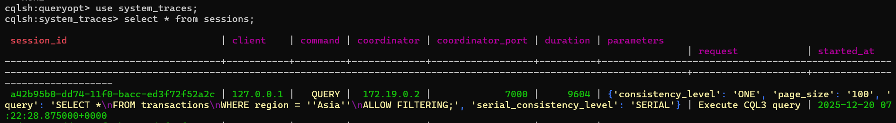



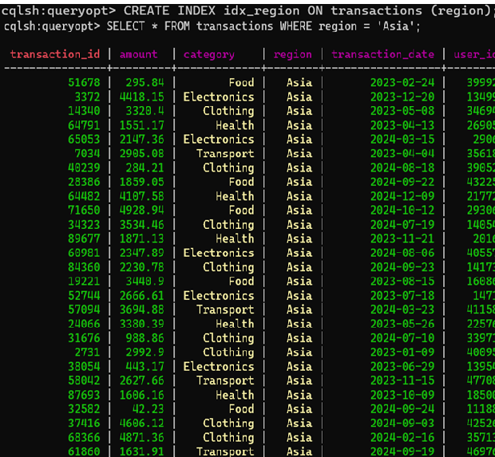

Cassandra 500K Q1

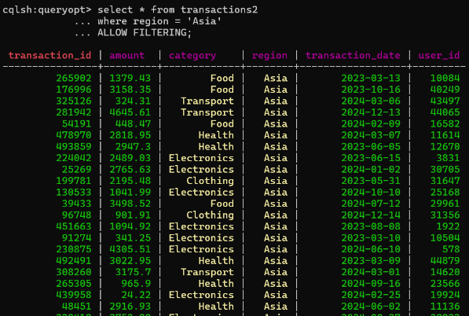

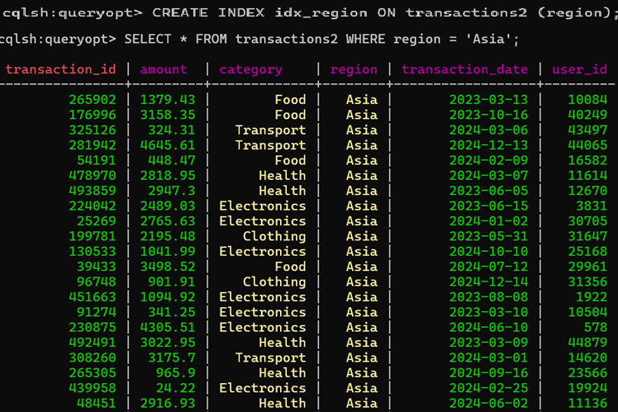

Cassandra 1000K Q1

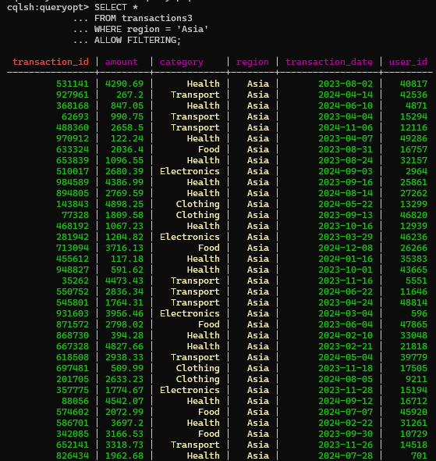

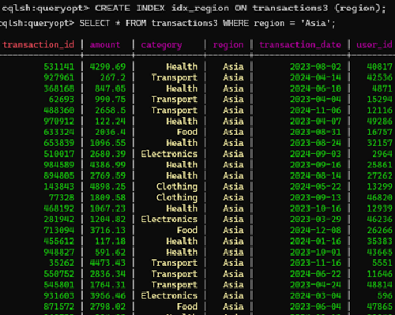

Cassandra 100k Q2

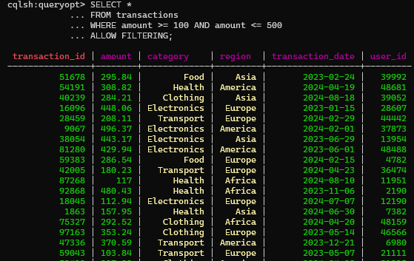

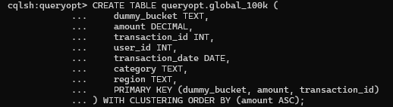

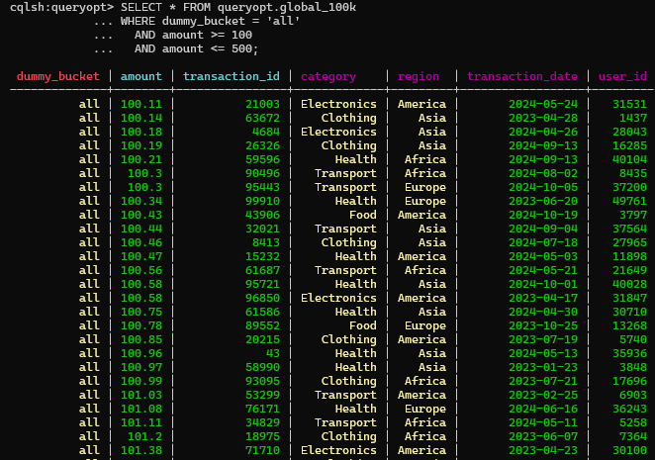



Cassandra 500K Q2

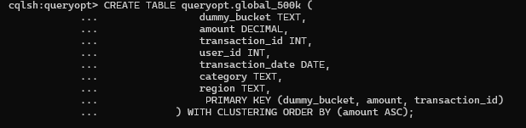

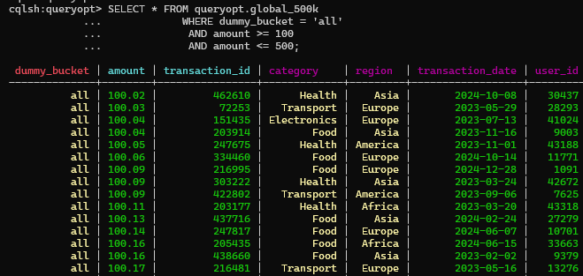

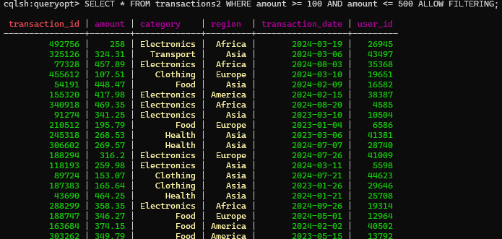

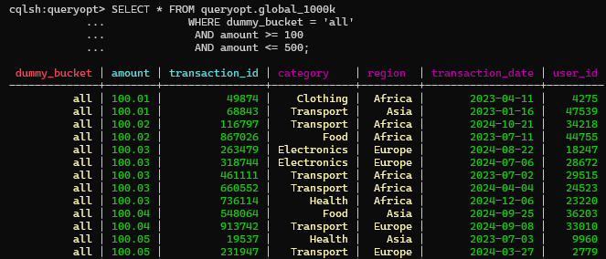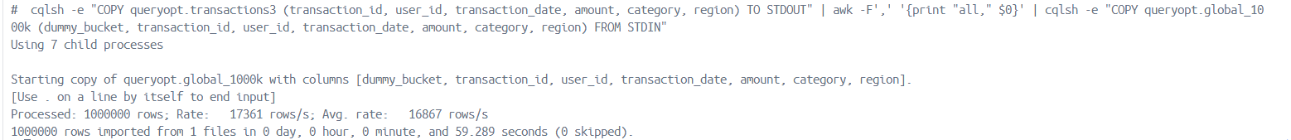Cassandra 1000K Q2

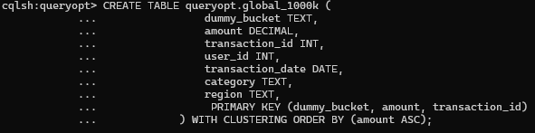



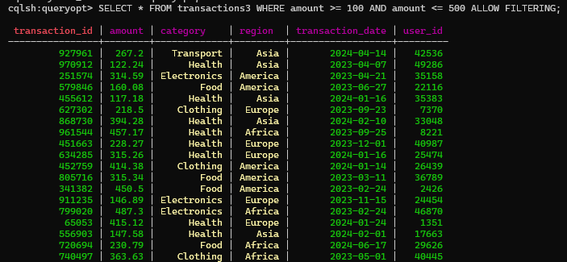

Cassandra 100K Q3

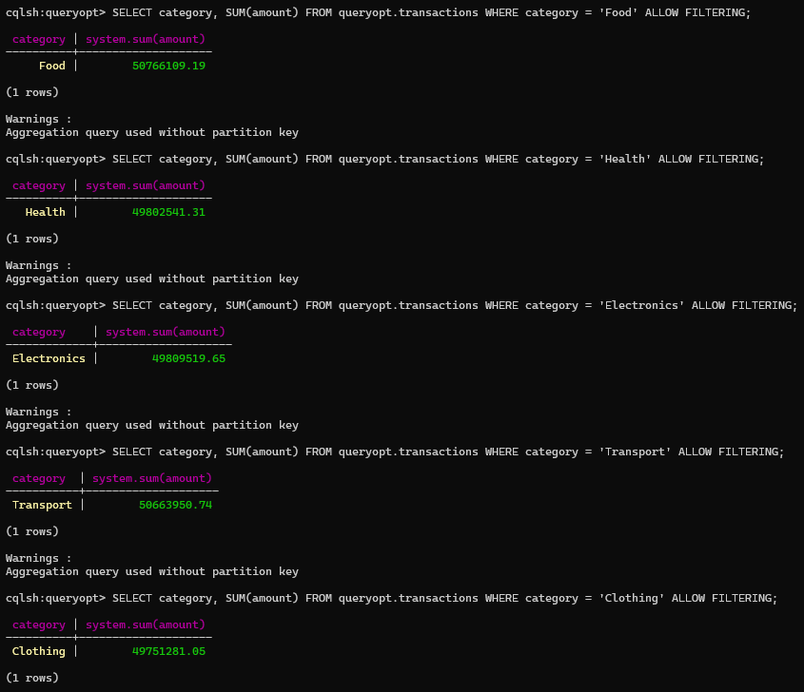



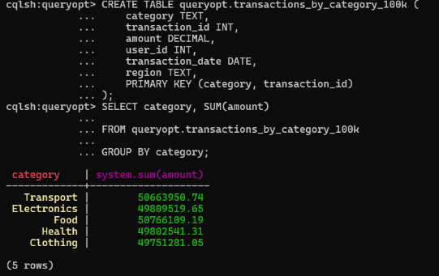



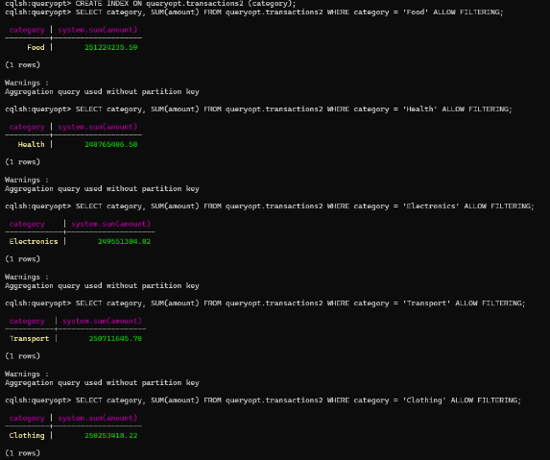Cassandra 500K Q3









Cassandra 1000K Q3

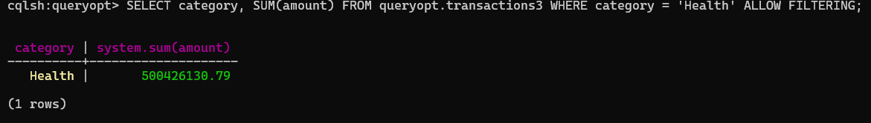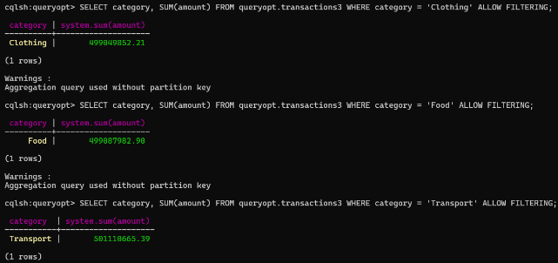









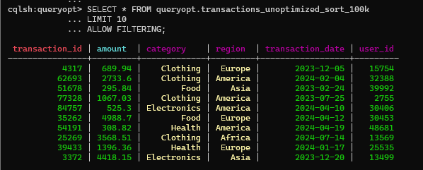Cassandra 100K Q4





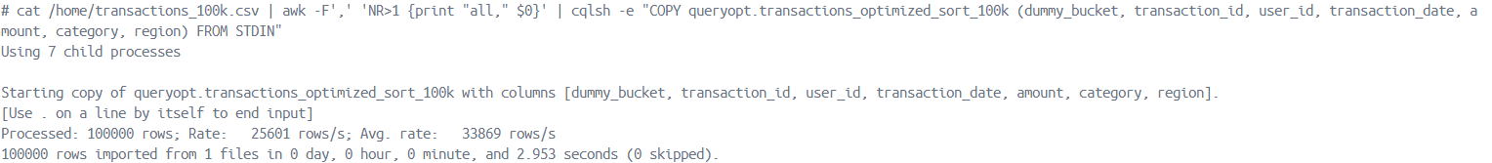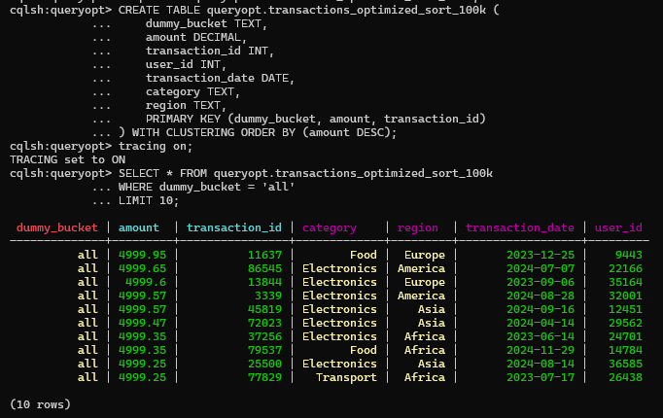



Cassandra 500K Q4

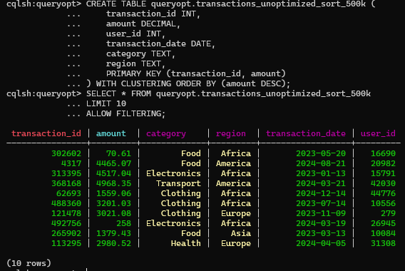



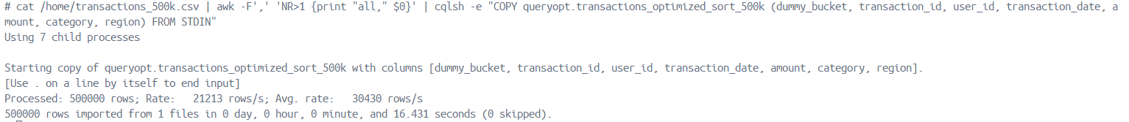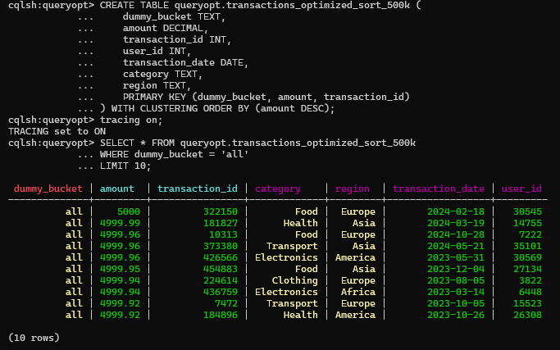



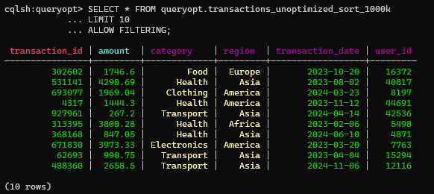Cassandra 1000K Q4





